**TEMPORARY EVENTS INFORMATION FORM FOR SITES WITHIN CATCHMENTS OF NUTRIENT-SENSITIVE SPECIAL AREAS OF CONSERVATION (SAC)**

**Please complete this form with as much information as possible**

|  |  |  |  |  |
| --- | --- | --- | --- | --- |
| **Applicant Name, Address and Contact details** | | **Agent Name, Address and Contact details**  **(If applicable)** | | |
| **Name:** |  | **Name:** |  | |
| **Address:** |  | **Address:** |  | |
| **Postcode:** |  | **Postcode:** |  | |
| **Telephone Number:** |  | **Telephone Number:** |  | |
| **Mobile Number:** |  | **Mobile Number:** |  | |
| **E-mail address:** |  | **E-mail address:** |  | |
| **Name/Description of Temporary Event** | | | |
|  | | | |
| **Proposed date(s) of temporary event on this site during the course of this calendar year [DD/MM/YYYY – DD/MM/YYYY]**  ***(Please include dates used to set up and take down of temporary structures, siting of tents trailers etc in connection with the temporary use of land)*** | | | |
|  | | | |

|  |  |  |
| --- | --- | --- |
| **Temporary Event Site Address** | | **Location Plan** |
| **Address:** |  | Please check the box below to confirm you have submitted a plan which identifies the land to which the temporary event relates, drawn to an identified scale and showing the direction of North and the site highlighted in red. |
| **Postcode:** |  | I have attached a location plan that meets the requirements outlined above: □ |

|  |  |  |  |  |  |
| --- | --- | --- | --- | --- | --- |
| **Foul Drainage information**  Please outline the proposed manner in which foul drainage will be managed as part of your temporary event i.e. whether you propose to use portable toilets or another method? | | | | | |
| Please confirm which of the following you are proposing to use – please include as much information as possible – appending further information if necessary: | | | | | |
| 1. Portable toilets – if so, provide details, including confirmation of how this is to be handled through a registered waste carrier disposal point to which the waste will be taken. | | | |  | |
| 1. An *existing* connection to a public sewer | | | |  | |
| 1. A *new* connection to a public sewer | | | |  | |
| 1. An existing private foul drainage system – if so, please confirm whether it is a:    * package treatment plant,    * septic tank    * cesspit    * Other/unknown | | | |  | |
| 1. Please also confirm whether this is known to discharge:    * to a watercourse    * to ground    * unknown | | | |  | |
| You will also need to provide information on the estimated number of people, to calculate the likely discharge flows; this should include staff as well as event attendees. | | | |  | |
|  | | | |  | |
| **Greywater drainage information**  Please outline the proposed manner in which greywater (i.e. from washbasins, showers, kitchen facilities) will be managed as part of your temporary event? | | | | | |
|  | | | | | |
|  | | | | | |
| **Other information**  Please confirm if any of the following will take place as part of the event or its preparation: | | | | | |
| 1. Installation of temporary bridge(s) over a watercourse – if so, provide details of  * the location(s), * whether any vegetation will need to be removed or cut back, * how the bridge will be secured in place | | |  | | |
| 1. Use of any external lighting – if so, provide details of  * the location(s) of lights * specific purpose * timings of operation | | |  | | |
| 1. Activities within a watercourse - please provide details, for example, swimming, paddling, raft race, etc. and the location(s) of entry and exit points along the riverbank. | | |  | | |
| **Has the view of Natural Resources Wales (NRW) been sought regarding whether the temporary event (including its foul drainage) is likely to have a likely significant effect on the Special Area of Conservation (SAC) (Usk, Wye or Tywi)?** | | | | | |
| Yes (please append a copy of the NRW dialogue) |  | | No | |  |
|  | | | | | |
| **Fee:**  **If Natural Resources Wales (NRW) response cannot rule out Likely Significant Effects, a fee of £30 is required for the Authority to process your application for written approval and undertake an Appropriate Assessment in consultation with Natural Resources Wales.**  I confirm that the relevant fee will be paid to the Authority by BACs once my written approval application has been registered and I have been notified of the reference number: □ | | | | | |
| **Signed (applicant):**  **Or**  **Signed (agent):** | | **Date (DD/MM/YYYY):** | | | |

*Mae copi o’r fflurflen hon ar gael yn y Gymraeg*

**PROCESS FLOWCHART**

Below is a brief flow-chart which aims to provide some further clarity on the process and next steps assuming that your temporary event on the above land do not exceed 28 days per calendar year:

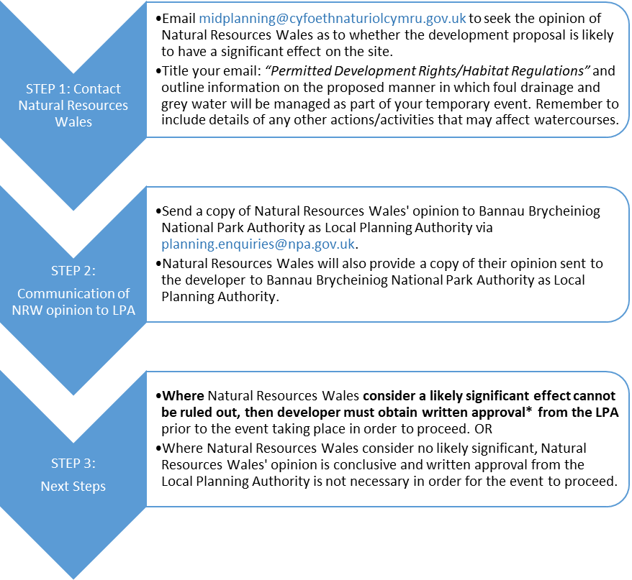

*\* An application for written approval will need to provide the Authority with your conclusion as to why you consider there are no adverse effects on the integrity of the Special Area of Conservation and an appropriate level of information, including any relevant mitigation measures. The form is intended to assist you in this regard. This information will then inform the Authority’s Appropriate Assessment which Natural Resources Wales will need to be consulted on, which in turn will inform the Authority’s determination of this application: There is a £30 fee for this written approval application.*