Bannau Brycheiniog National Park Authority
Environment (Wales) Act 2016 Part 1 – Section 6
The Biodiversity and Resilience of Ecosystems Duty
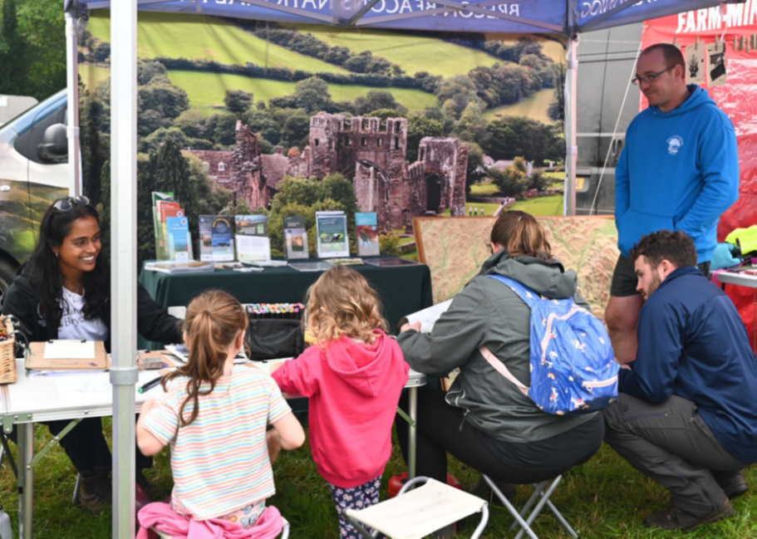
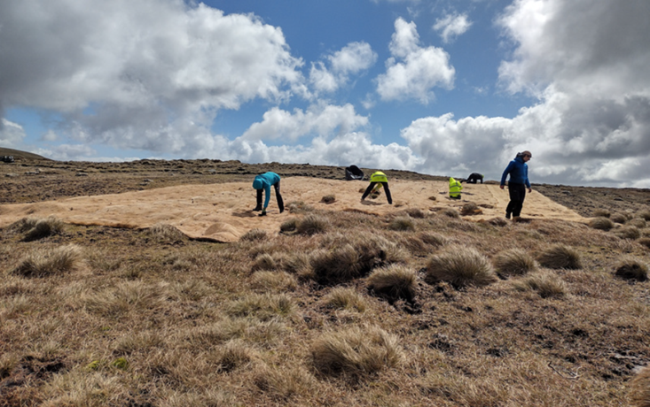
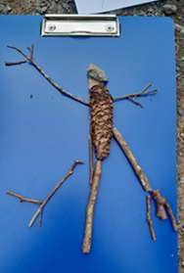
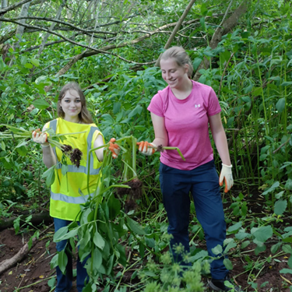
Report, 2023 – 2025

[Front Page Photos, clockwise from top left; Sennybridge show, Eurasian Curlew, Curlew nest, jute matting and heather spreading to aide peatland restoration with wardens and volunteers, education team nature art (newt), drystone walling, Himalayan balsam pulling with work experience students]

Environment (Wales) Act 2016 Part 1 - Section 6
The Biodiversity and Resilience of Ecosystems Duty
Report
January 2023 - December 2025
Bannau Brycheiniog National Park Authority
Introduction and Context
This report describes some of the ways in which the Bannau Brycheiniog National Park Authority has met its obligations under the Section 6 Biodiversity Duty. It leads on from Bannau Brycheiniog National Park’s second Section 6 Report (in 2022).
Despite some challenges this reporting period, the Authority has continued to play a significant role in the Welsh response to the universal decline in biodiversity and embedding biodiversity across its activities. This has been delivered across the Authority’s many roles, including as a major landowner, active member of a variety of biodiversity-based partnerships and initiatives, and as a Local Planning Authority. Biodiversity conservation and nature recovery remain a core part of Bannau Brycheiniog National Park’s functions.
Appendix 1 provides examples of actions taken in support of the Section 6 duty. These have been provided by Officers from across the Authority. Many of the actions align with more than one of the All-Wales Nature Recovery Objectives. Selected examples are described in more detail below.
Context
Bannau Brycheinog National Park is one of a family of fifteen National Parks in the UK. It received formal designation in 1957 and measures 520 square miles, supporting a population of over 33,000 people. The border extends from the rural heartland of Mid Wales in the north to the post-industrial ex-mining communities of the South Wales Valleys at is southern fringes. From east to west the Park spans from the borders to the fringes of Llandeilo.
Bannau Brycheiniog National Park Authority is the body which is charged by law to look after the rich and special landscapes of the National Park. It has two statutory special purposes. These are:
- To conserve and enhance the natural beauty, wildlife and cultural heritage of the National Park.
- To promote opportunities for the understanding and enjoyment of the special qualities of the National Park by the public.
The law also states that in carrying out these purposes the Authority must also seek:
- To foster the economic and social well-being of local communities within the National Park.
Over 90% of the Park’s primary land use is farming, 35% is registered common land (mostly upland), about 30% is designated as Sites of Special Scientific Interest including over 60 biological SSSIs with at least 163 biological interest features and 11 Special Areas of Conservation (SACs). Sixty five percent of the Park is owned privately and 35% is owned by public bodies, NGOs and privatised utilities. Bannau Brycheiniog National Park is the Park’s largest landowner, at just under 15% (of which approximately 21% is Site of Special Scientific Interest).

Policy and legislative context

Bannau Brycheiniog National Park operates within a statutory and policy framework that includes:
- Environment (Wales) Act 2016 (including the Section 6 biodiversity duty)
- Well-being of Future Generations (Wales) Act 2015
- Planning legislation
- Welsh Government remit letters and funding agreements

Together, these require the Authority to integrate biodiversity, sustainable development and ecosystem resilience across all functions.

Dyfodol y Bannau – National Park Management Plan

Bannau Brycheiniog National Park’s work is guided by the Dyfodol y Bannau National Park Management Plan, adopted in 2023. This sets a long-term vision based on the sustainable development principle and establishes a mission-led approach to delivery.

The Plan is structured around five Missions:
- Climate: Reach net-zero greenhouse gas emissions across Bannau Brycheiniog National Park by 2035.
- Water: Clean, safe, resilient and plentiful water resources and water environments by 2030.
- Nature: A nature positive Bannau Brycheiniog National Park by 2030.
- People: Living, working, visiting – safely, equitably, and sustainably for Bannau Brycheiniog.
- Place: Thriving, beautiful, prosperous and sustainable places, celebrated for their cultural and natural heritage, now and forever.

Nature recovery underpins all five Missions, reflecting the interdependence of biodiversity, climate, water and community outcomes.

Section 6 duty and Nature Recovery Action Plan

The Authority delivers its Section 6 duty through the National Park Management Plan including:
- Direct nature recovery activities on Bannau Brycheiniog National Park-owned land, and on other land in the National Park
- Working in partnership with the Local Nature Partnership to deliver the Nature Recovery Action Plan (NRAP).

This report is structured around NRAP objectives to show how actions contribute to maintaining and enhancing biodiversity and ecosystem resilience.

Applying SMNR principles

Bannau Brycheiniog National Park’s approach aligns with the principles of Sustainable Management of Natural Resources (SMNR):
- long-term thinking
- ecosystem resilience
- collaboration
- evidence-based decision-making

Delivery reflects SMNR principles, for example, through:
- long-term peatland restoration
- catchment-scale approaches
- diverse and connected habitats
- adaptive management informed by monitoring

The Authority is increasingly applying a whole-system approach, recognising the functional relationships between upland and lowland systems, where land management in upper catchments influences downstream water quality, flood risk and habitat condition.

Looking ahead

The Authority is strengthening its approach to integrated planning, monitoring and reporting. The establishment of a Performance, Risk and Compliance function will support better alignment across plans and improve evaluation of outcomes.

Further work is needed to:
- strengthen monitoring and evidence frameworks
- understand the most impactful interventions for nature in a climate-challenged future
- scale delivery by Bannau Brycheiniog National Park and in partnership
- improve integration across planning and reporting

This includes exploring new approaches to landscape-scale monitoring and adaptive management to support faster learning, more effective long-term decision-making, and strengthened ability to attract funding.

We are also exploring new ways to finance nature recovery in the National Park. For example, pilot work in the Upper Usk South area is exploring the potential for blended finance models to support long-term, landscape-scale restoration. This work is intended to grow over the coming years.

Highlights, Key Outcomes and Issues

Highlights & Key Outcomes
There has been substantial progress across multiple nature recovery projects, landscape-scale initiatives, partnerships and funded programmes within Bannau Brycheiniog National Park.
Ffermio Bro - Farming in Designated Landscapes Scheme, commenced in May 2025 and in its first year saw significant uptake and success in Bannau Brycheiniog National Park, supporting farmers to make improvements for nature and the environment within the Park. Funding was granted for more than 1,700 metres of new hedgerow, while the team conducted 55 farm visits and approved 42 projects. Total expressions of interest exceeded the £325,000 capital allocation, demonstrating strong community engagement and demand for nature-friendly farming support.
Bannau Brycheiniog National Park remains a leading part of upland peatland restoration within Wales. Its sizable peatland restoration programme, and contribution to the development and delivery of best practice (guided by Bannau Brycheiniog National Park’s Peatland Strategy) continues to be a core feature of the National Park Authority’s work.
Peatland restoration and upland path restoration works have taken place on multiple sites across the Park, engaging a variety of techniques. In 2024–25 alone, the National Park restored 28 hectares of peatland, a 133% increase on the previous year’s total. A further £1.75 million has been secured to support peatland restoration over the next three to five years, recognising the essential role peatlands play in carbon storage, biodiversity and water management.
A core group of dedicated volunteers have undertaken field surveys using a Bannau Brycheiniog National Park adapted version of the Peatlands Rapid Assessment methodology. Providing valuable data to aide decision making and targeting of future restoration works.
The Team continues to be an active contributor to peatlands research and practice in Wales, with an ambition to develop a Peatland Evidence Platform in Bannau Brycheiniog National Park underway, and sponsorship of the InSAR remote sensing pilot project being led by Swansea University.
Bannau Brycheiniog National Park has been an integral part of the development and delivery of Curlew Connections Wales, a £1million Nature Networks funded project to support conservation of this iconic species, focussing on 3 Important Curlew Areas (including the Usk Catchment and Llangorse Lake area within Bannau Brycheiniog National Park). The project has aimed to tackle some of the key issues driving low breeding success of curlew, monitoring and understanding curlew populations and working with farmers and landowners to implement nest protection, predator management and habitat works.
Bannau Brycheiniog National Park continues to be a lead Partner within the Brecon Beacons Local Nature Partnership (BBLNP) and a plan to refresh the Local Nature Recovery Action Plan is underway. With a goal to review alignment with the Missions agreed within Y Bannau and consider progress towards each of the NRAP objectives, to date. This will build on a review of the NRAP undertaken by the National Park Authority in conjunction with BBNLNP in March 2023.
Thanks to WG Local Places for Nature (LPfN) Revenue and Capital funding allocations, the Authority has been able to host a LNP Projects Officer, who has coordinated a diverse programme of local biodiversity activities, which have included:
- Support and training for Town & Community Councils (T&CC) around Section 6 delivery, including a well-received Nature Recovery information day, production of T&CC biodiversity reports and T&CC Connector Grant scheme supporting on the ground biodiversity enhancements.
- Production and launch of “The Brecon Nature Walks” guided nature walk series.
- Support for local wildflower seed harvesting and sowing, plus construction and piloting of a LNP seed drying facility.
- Establishment of 3 Community Local Provenance Tree Nurseries. Which, alongside the above forms part of longer-term goals to establish greater availability of local provenance plants for Bannau Brycheiniog National Park projects and schemes.
- Construction of a bat house to provide new roosting opportunities & involving volunteers to build bat boxes.
- Delivery of a Hedge-laying Connector Grant scheme (across 19 farms, with c4km of hedgerows laid)
Bannau Brycheiniog National Park’s involvement in the LPfN programme and associated LNP Cymru Partnership is seen as vital for capacity building, awareness raising and implementation of nature recovery goals in line with the Park’s Nature Recovery Action Plan.
Other highlights have included Bannau Brycheiniog National Park’s role as key Partner within the £9 million Four Rivers for LIFE programme, led by Natural Resources Wales and covering a wide range of biodiversity enhancement measures. Bannau Brycheiniog National Park have supported at both a governance and delivery level within the River Usk component, including an Invasive Non-Native Species (INNS) programme supported by the in-house INNS expertise which the Park has established.
Bannau Brycheiniog National Park working closely alongside The Woodland Trust, commissioned a Treescapes Situation Analysis, informing the drafting of a Treescapes Action Plan for the Park. Engaging with sector experts, this has helped secure a better understanding of the existing treescape resources in the Park and identify some strategic recommendations for how to improve and expand this resource.
A key strand throughout the National Park Authority’s work is supporting opportunities for engagement and education around biodiversity and the well-being benefits it affords. For example:
- Education team engagement with over 6,000 schools during outdoor educational activities which have included biodiversity activities encouraging learning around habitat types, species identification, carbon storage and river function. As part of the Rivers 4 LIFE project, the team has also delivered sessions to over 7 schools in the Usk catchment to improve students’ knowledge of their local river, the challenges it faces and work being undertaken to improve its condition.
- Delivery of an annual Work Experience programme for students aged 15-17 years offering hands on experience, working alongside wardens, ecology, education and policy team.
- Continuation of the successful Youth Warden Scheme, an outdoors programme for young people aged 15-18 years, supporting development of new skills. Youth Wardens meet once a month during the academic year and have engaged in activities such as bat box making, hedge laying, tree planting.
Key challenges
Despite progress, several constraints continue to limit impact:
- climate-related pressures, including wildfire and extreme weather, are increasing and are reversing some gains
- the overall scale of action remains insufficient to reverse biodiversity decline
- reliance on short-term funding restricts long-term planning and continuity
- monitoring systems are not yet robust or integrated enough to demonstrate cumulative change or sufficiently support adaptive management at a landscape scale
- capacity constraints continue to affect delivery pace and consistency
- the scale and complexity of upland common land presents a significant delivery challenge for nature recovery, including wildfire management, peatland restoration and coordinated grazing, requiring resource-intensive collaboration across multiple rights holders.
- Visitor numbers and behaviour is putting significant pressure on important and fragile ecosystems.

These challenges highlight the gap between current activity and the level of change required.
Progress under this objective has strengthened the Authority’s evidence base through improved data collection, monitoring, mapping and access to shared tools.

Evidence, understanding and monitoring challenges

Investments in GIS capability, biological recording and natural capital development are supporting more informed decision-making and better targeting of interventions.

There has been a clear shift in Bannau Brycheiniog National Park’s work toward a more integrated, spatially-informed evidence system, although current monitoring remains fragmented, with limited shared indicators and baselines.

Further development is needed to link activity to measurable ecological change, support adaptive management and demonstrate progress at a landscape scale.

A refreshed Nature Recovery Action Plan is anticipated to include indicators and a monitoring framework to link action to impact.

This report reflects that gap in capability and ways of working and does not articulate how the Authority’s activities are amassing and contributing towards nature recovery goals.

Action Report

NRAP Objective 1: Engage and support participation and understanding to embed biodiversity throughout decision making at all levels.
Actions to embed biodiversity action across your organisation’s functions.
Progress under this objective shows increasing awareness, skills and organisational capacity across the Authority, supporting more consistent and earlier consideration of biodiversity in decision-making.
Training, staff engagement and communications have strengthened understanding of ecological issues and trade-offs, while community and volunteer activity has widened participation in nature recovery.

Together, these changes are beginning to embed biodiversity as a shared responsibility across the organisation and its partners, although further work is needed to ensure consistent application across all services and processes.

Examples | Measures and/or indicators monitored
National Park Management Plan (Y Bannau – The Future)  On 17 April 2023 the National Park Authority published a new management plan for the National Park which set out five interrelated missions including Climate - reach net zero greenhouse gas emissions across the National Park by 2035; Nature - a nature positive Bannau Brycheiniog by 2030; and Water - clean, safe, resilient and plentiful water resources and water environments by 2030. The missions guide the work of the National Park Authority in relation to our own operations and land, and the work we undertake with partners, stakeholders and communities. The plan embeds nature recovery at its core, with a recognition that many of the issues facing the Park and wider society can be addressed by taking a nature-based model of action, creating holistic outcomes that benefit all.  Y Bannau, supported by the Bannau Brycheiniog National Park Nature Recovery Action Plan (and alongside the Authority’s Corporate Plan) constitute the Authority’s Section 6 Plan. Together they help embed biodiversity and nature recovery across the Park’s activities and decision-making functions. A plan to refresh the NRAP is underway in keeping with changes to the All Wales NRAP and to ensure alignment with the Missions within Y Bannau. | Revised National Park Management Plan was published April 2023.  Includes a set of key indicators of success within five years including in relation to landuse change, habitat restoration, sustainable farming, resilient water catchments, species conservation, and ecosystem management.  Bannau Brycheiniog National Park NRAP (being refreshed)
Welsh Government Biodiversity Deep Dive and diversity-related consultations  Bannau Brycheiniog National Park was part of the Core Group and specialist groups for Designated Landscapes, OECMs and NREAs and Monitoring and Evidence. Now part of the Strategic Implementation Group and Designated Landscapes Specialist Group.  Policy staff and other officers regularly provide comments (including on biodiversity) to official responses to various consultations (e.g., Welsh Government Sustainable Farming Scheme, Natural Resources Wales, etc.). This can be as part of a joint National Parks Wales response, or individual Bannau Brycheiniog National Park response, depending upon the consultation. | Reports published, now assisting Strategic Implementation Group.
Local Development Plan (Local Development Plan)  The Local Development Plan is a key mechanism for the delivery of the Missions within Y Bannau. The process to ensure a revision of the current Local Development Plan has been initiated.  Recruitment for a Planning Strategy & Policy Manager is currently underway. This will be core to the preparation, examination and adoption of the new Local Development Plan. | Local Development Plan Review Team timetable.
Changes to staff with core biodiversity element to their roles  Permanent posts: across the last period:  The former Senior Ecologist (Nature Recovery) role has been subsumed into a new post: Land Use and Nature Recovery Manager. The Authority also has a Senior Ecologist (0.8 FTE), 2 part-time Ecologists (1 FTE), 2 Planning Ecologists, a Nature Recovery Officer, a Biodiversity Liaison Officer (0.8 FTE) and a LNP Coordinator (0.6 FTE – operating as part of Project & Partnerships role).  Additional fixed term/project funded posts include Peatland Project Officer Local Nature Partnership Projects Officer, Ffermio Bro Project Officer, Woodlands Officer (0.4FTE), Manor Penderyn Project Officer (0.6FTE).  Recruitment for a 2nd Ffermio Bro Project Officer and a Planning Ecology Technician is underway. | Comparative increase this period in FTE targeted Ecology staff (due to fixed term/project funding & the revised status of Nature Recovery Officer and Biodiversity Liaison Officer roles as permanent posts).
Business as usual
Given its two primary purposes, the whole of Bannau Brycheiniog National Park is focussed on delivering nature recovery action as a major part of business as usual.
Actions to raise awareness across the organisation.
Examples | Measures and/or indicators monitored
Staff and Member biodiversity training/awareness raising  Face to face Member Development Session were reignited this reporting period, including nature recovery and management of protected sites sessions at the National Park Authority’s landholdings at Llangasty and Mynydd Illtyd. Members have also had the chance to explore peatland restoration in the East of the Park with the Peatlands and Wardens Teams.  All Staff Days have included sessions with a nature recovery focus, for example a vision planning exercise for Upper Usk South focal area and a “hands-on” upland non-native tree sapling removal day in the West of the park. Staff have also been supported to participate in Himalayan balsam pulling at Cwm Bwchel, training sessions on curlew awareness and native black poplar, and annual red grouse monitoring in the Black Mountains.  Plans are underway to encourage more biodiversity themed sessions within the programme of “Inspire” and “Insight” staff training sessions that have started to run. This will include a session on biodiversity and the Section 6 Duty. | 2+ nature recovery themed Member Training days held.  3+ nature recovery themed All Staff Day opportunities supported.
Bannau Brycheiniog National Park communications, internal & external newsletters  The Bannau Brycheiniog National Park Communications Team have delivered integrated communications support around nature recovery and work being undertaken across the Authority. Including biodiversity stories, event message, social media campaigns, supporting nature-based campaigns (for e.g. Wales Nature Week) and calendar days and website updates. This has supported raised public awareness and improved visibility of biodiversity priorities across all Bannau Brycheiniog National Park engagement channels.  From 2024, a Weekly Update (internal e-newsletter) has been compiled, covering brief news and updates from across Bannau Brycheiniog National Park and providing updates on nature recovery related initiatives and forthcoming events and opportunities to get involved. | Weekly E-news for staff featuring nature-based news stories.  Copies of newsletters, press releases, social media data monitored by Comms Team.
Brecon Nature Walks Leaflet  This series of walks captured within a leaflet, explores the green spaces and wildlife of Brecon and was produced by the LNP with input from Bannau Brycheiniog National Park. Staff were encouraged to help trial the proposed routes, check ecological and other detail and learn more about the LNP. Staff have been encouraged to try out the walks during lunch and breaks to help promote well-being and knowledge of biodiversity on Bannau Brycheiniog National Park HQ’s doorstep.  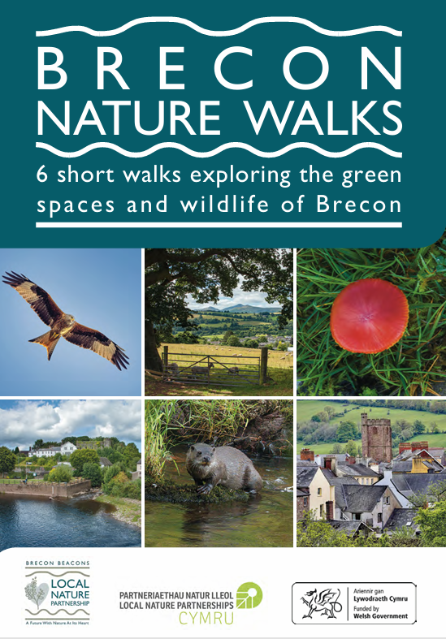  Photo: Brecon Nature Walks leaflet cover | 1500 hard copies distributed, and available online.  Staff engagement day to pilot the walks.
NRAP Objective 2: Safeguard species and habitats of principal importance and improve their management
Including:
Actions taken to safeguard principal species and habitats.
Actions to contribute to the management of protected sites and species, including Local Wildlife Sites/Sites of Importance for Nature Conservation
Examples | Measures and/or indicators monitored
Planning  The Authority continues to provide first class planning and wildlife advice to Development Management and Enforcement Officers. Approximately 400 planning applications are responded to per year. The majority of planning applications include requirement for biodiversity enhancement measures to be delivered when the development is implemented.  The requirement for Habitats Regulations Assessments (HRA) screening and Appropriate Assessments of applications has been overseen by Planning Ecology. Following new evidence about the environmental impact of phosphate in watercourses and the subsequent adoption of tighter water quality targets by Natural Resources Wales, there has been a significant increase in the number of HRAs in the period 2021-22.  Development Management and Enforcement Officers have also received a suite of training on biodiversity and environmental legislation. | Approx. 400 planning applications responded to per year.  From 2023, c.30 Appropriate Assessments per year.  Biodiversity training provided to Development Management Officers.
Examples of targeted biodiversity enhancements on Bannau Brycheiniog National Park landholdings  The following are instances of different species-focussed initiatives, providing small scale examples of cross team working, and engagement with the Planning Team and those on the ground to deliver best practice.  Sand Martin Nesting Bank  In response to a proposal from Llangorse Ringing Group, the Ecology Team assisted the group through the process of gaining planning permission and protected sites consent for installation of a sand martin nesting bank on National Park Authority owned land on the Southern shores of Llangorse Lake. The bank which will be monitored and maintained by the Ringing Group offers a nesting opportunity to martins who already gather and feed over the lake, and whose nearest natural nesting sites on the banks of the River Usk have been washed away in some places in recent years.  Dipper Nest Box Project  The Warden Team initiated the project in late 2025, focusing on improving nesting opportunities along key sections of the Rights of Way network. With LPfN funding and local ecological advice, tailored nest boxes were installed at 9 sites across the eastern and central parts of the National Park, with more planned. The project has also offered opportunities for young people through the Youth Warden Scheme, whose members helped make additional nest boxes.  Photo: Newly installed dipper nest box, below Rights of Way bridge  Bat House  Overseen by the Nature Recovery Officer and with input from LNP Projects Officer and Wardens Team, a contractor was engaged to construct a bat house within a derelict building on the Govilon Line and Youth Warden volunteers assisted with building bat boxes as part of project. The design drew on the experience of the Nature Recovery Officer in bat conservation and secured Planning approval. It provides new bat roosting opportunities, will be monitored and attracted much interest from local walkers during its construction. | 9 Dipper nest boxes installed on Rights of Way Bridges.  1 Bat House constructed.  Sand martin nesting bank installed.
Sites of Importance for Nature Conservation  A revision of the Authority’s Sites of Importance for Nature Conservation criteria was conducted last reporting round, alongside a review of the suite of Sites of Importance for Nature Conservations within Bannau Brycheiniog National Park. Sites of Importance for Nature Conservation maps have been made available for RENS mapping and other landscape initiatives within the Park.  BIS were commissioned to map the Bannau Brycheiniog National Park Sites of Importance for Nature Conservation criteria for key habitats within the Park. This helps to highlight potential nature-rich areas beyond the current statutory/Sites of Importance for Nature Conservation sites system in Bannau Brycheiniog National Park, to (resource willing) help target future Sites of Importance for Nature Conservation field surveys, and aide nature recovery action planning.  Advice was provided to landowners of potential Sites of Importance for Nature Conservations and efforts were made to ensure current Sites of Importance for Nature Conservation owners were aware of the Bannau Brycheiniog National Park Landowners Working for Nature Grant Scheme (part of Sustainable Landscapes Sustainable Places funding). | Bannau Brycheiniog National Park Sites of Importance for Nature Conservation criteria guidance document published.  Bannau Brycheiniog National Park Sites of Importance for Nature Conservation Criteria maps (for selection of priority habitats). GIS files.  Sites of Importance for Nature Conservation Assessment Panel reformed.  Nature recovery management advice to c10 potential Sites of Importance for Nature Conservations.
Curlew Connections Wales  Bannau Brycheiniog National Park has been a core part of this £1million Nature Networks funded project to support conservation of this iconic species, focussing on 3 Important Curlew Areas (including the Usk Catchment and Llangorse Lake area within Bannau Brycheiniog National Park). The project has worked with farmers and volunteers to locate and monitor curlews within the Usk ICA and advise and employ conservation measures to support the species. This has been supported by engagement and training events, targeted capital habit management payments, curlew nest fencing and predator management.  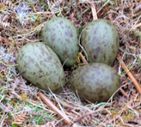  Photo: Curlew nest | 18 pair of curlews monitored annually.  32+ farmers worked with, 20 of these received grants/capital habitat management payments.  500+ volunteer hours (2024 & 2025).  30+ volunteers trained to survey curlews.  10 farmers/ gamekeepers trained in predator management.  30 curlew events organised/attended with 1000+ people engaged.
Bannau Brycheiniog National Park owned land and Protected Sites  Many of the activities within this report are delivered across land which the Authority owns and/or involve Protected Sites - taking place at different scales and thanks to different funding programmes, partnerships and initiatives. Examples include:  - Hatterrall Ridge (Black Mountains SSSI) – updated management plan produced, reviewed and approved by Natural Resources Wales for the next 3 years. This has enabled permissions and management certainty for the National Park Authority’s land here and planning into Warden work schedules.  - Mynydd Illtyd – Traeth Mawr (SSSI) – through discussion with Natural Resources Wales, Commoners and graziers, a way forward with tree removal and Molinia management has been agreed, and SSSI consent secured, offering positive steps towards improving condition of the SSSI habitat features.  - Southern shores of Llangorse Lake (SSSI) – cattle grazing secured for the first time in over 25 years on Caeau Ty Mawr SSSI through a new Tenancy Agreement with a local farmer. Plans underway to repair the Bird Hide to ensure it can continue to be enjoyed by visitors, as a key part of the site’s infrastructure, and access for people to nature.  - Extensive upland peatland recovery works across key upland SSSIs (see Objective 3, below).  - Catchment scale partnerships - The Authority is an active part of a variety of partnerships including being host to the Usk Catchment Partnership, which is developing an evidence-based action plan to aide delivery of outcomes relating to water quality, flood risk, nature recovery, and resilient communities.  - Mynydd Iach Penderyn - Penderyn Healthy Mountain project – Nature Networks 4 funding was secured for a Project Officer to work with the Partnership to build capacity and collaborate to deliver nature recovery and networks and sustainable agriculture on Manor Penderyn common. | Various. Management plans, SSSI consents in place.  Usk Catchment Partnership Project Manager, Terms of Reference, Chair in place.  Draft River Usk Nutrient Management Plan.  Mynydd Iach Penderyn Project Officer secured until 2028.
NRAP Objective 3: Increase the resilience of our natural environment by restoring degraded habitats and habitat creation
Actions to create or contribute to Resilient Ecological Networks, for example restoring or creating habitats, improving the management and/or diversity or areas of habitat.
Examples | Measures and/or indicators monitored
Upland Access and Peatland Restoration programme  The Bannau Brycheiniog National Park Peatlands Team continues to lead and innovate in an ongoing, large-scale programme of works, to support the restoration degraded upland habitats at a variety of key sites and share best practice. With funding secured through a variety of sources and working with skilled contractors and volunteers.  A volunteer peatland survey programme employs a core team of regular volunteers, using an adapted version of Rapid Peatland Assessment methodology and providing valuable data to aide decision making and targeting of future restoration works.  Bannau Brycheiniog National Park is a member of the National Peatlands Action Practitioners Group, Science and Evidence Group and Strategic Partners Group, continuing to provide specialist advice and guidance, including the aim to develop Wales first Peatland Evidence Platform in Bannau Brycheiniog National Park, and sponsoring an InSAR remote sensing pilot project being led by Swansea University.  Table 1: Indication of Upland Access and Peatland restoration works 2022-25. Across sites including Ystrad (Waun Rydd), Waun Fach, Waun Wen, Carig y Fan Ddu, Pen Trumau, Waun Fignen Felen, Central Beacons and Llyn y Fan Fawr.  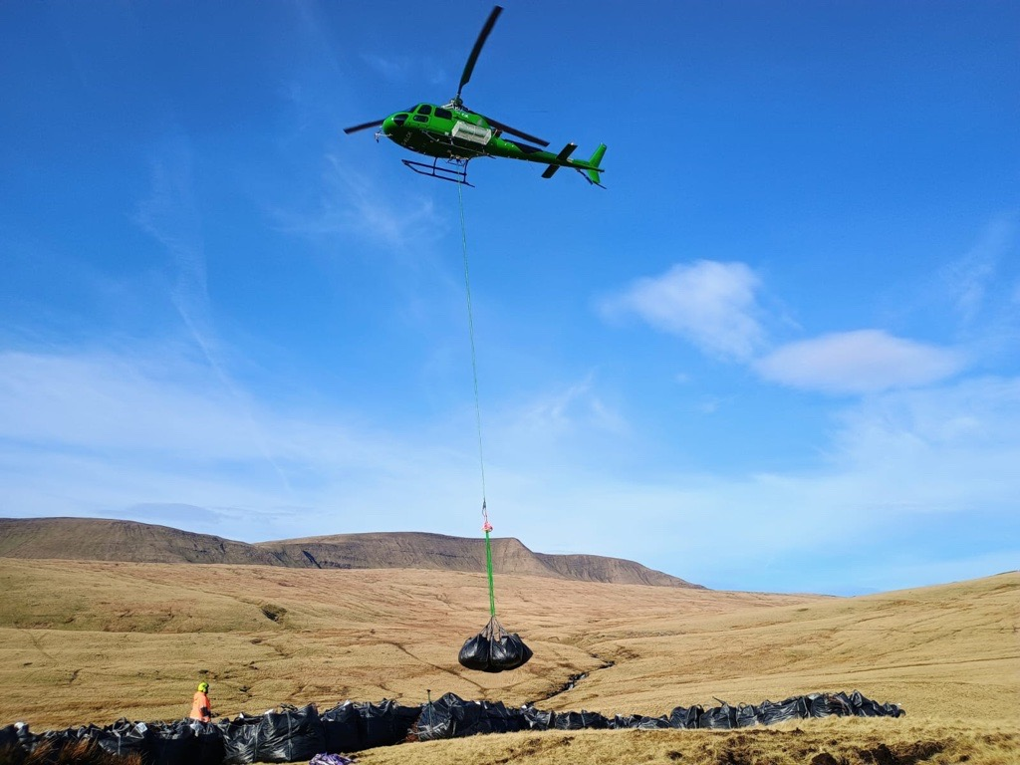  Photo: Airlift of materials with Wardens Team | Peatland condition monitoring and fixed-point photography.  Hydrological monitoring installed on seven long-term restoration sites.  Peatland Restoration Strategy for Bannau Brycheiniog National Park in place.  Volunteers have surveyed over 1200 plots to date (including peat depths and percentage of upland vegetation types for 10m2 quadrats).  Initial Peatlands Evidence Platform workshops held, InSAR project commissioned.  See Table 1 for peatland outputs.
  Peatland Restoration Physical Outputs
  2022-23
  Total 12951m of peat hagg reprofiling
  57 timber dams
  1.6ha of bare area treatment.
  2023-24
  Total 4247m of peat hagg reprofiling
  200 peat dams
  84 gabion stone dams
  22 timber dams
  75 3m coir sausage dams
  84 1m wool sausage dams
  1.7ha of bare area treatment
  2024-25
  21331m of peat hagg reprofiling
  126 peat dams
  160 gabion stone dams
  178 3m coir sausage dams,
  550m of contour bunds
  98m of zippered drain
  2.3ha of bare area treatment
Connecting People to a Wilder Tarrel Valley Project  BBLNP coordinated a successful bid to the Welsh Government Challenge Fund, in partnership with the National Trust, Plantlife, Bannau Brycheiniog National Park and others. The funding supported the NT’s goal to begin re-naturalisation of its land holding at Ty Mawr (formerly an intensively farmed lowland site), working with local partners and establishing education and volunteer facilities. Capital works included native tree planting, river restoration work, fencing to support grazing, creation of a Sphagnum moss nursery, hay meadow enhancement using native seed sowing, hedgerow restoration and planting. A local wildflower seed drying facility was also designed and installed on site, funded through the LNP’s Local Places for Nature Funding allocation. | WG Challenge Fund Award.  WG project KPIs & Project Report.
Ffermio Bro – farming in designated landscapes scheme  Commenced in May 2025, overseen by a newly recruited Project Officer and other staff and seeing remarkable success in year 1; with heightened interest from farmers across the National Park, and demonstrating the impact of collaborative, landscape scale action for nature recovery.  Funding was granted for more than 1,700 metres of new hedgerow, while the team conducted 55 farm visits and approved 42 projects. Total expressions of interest exceeded the £325,000 capital allocation, demonstrating strong community engagement and demand for nature-friendly farming support.  Photo: Wildflower seed harvesting sieving, as part of Ffermio Bro funding | Project Officer in post, grant scheme now being delivered, Local Assessment Panel in place; workshop completed to draft Years 2 and 3 of the scheme.  2nd Project Officer being recruited.
NRAP Objective 4: Tackle key pressures on species and habitats
Including:
Actions to address key pressures.
Use of biodiverse and native nature-based solutions wherever possible.
Examples | Measures and/or indicators monitored
Tackling Invasive Non-Native Species  Bannau Brycheiniog INNS monitoring and control programmes, or action took place for the following species across the period: Japanese knotweed, Himalayan balsam, Giant hogweed, Bamboo, Cherry Laurel, Rhododendron, American Mink, American Signal Crayfish, American skunk cabbage, Crassula helmsii. Volunteers played a crucial role with these programmes, contributing directly to improved biodiversity and safer public access.  Leading on from previous years’ work, efforts have majored on trying to sustain the systematic control of Japanese knotweed in the Upper Usk (SSSI, SAC), alongside Himalayan balsam control on the two major catchments: the Usk and Tawe. Work has demonstrated the sustained effort required to secure long standing control of INNS.  This included INNS biocontrol programmes, with trial of Himalayan balsam rust fungus and Crassula helmsii mites. These ongoing trials will help assess feasibility of using biocontrol to tackle specific INNS.  The team has also provided INNS training days for volunteers and staff.  Photo: Rhododendron control, Cribarth | Year 5 of River Usk Japanese knotweed control programme completed. Japanese knotweed quantity along River Usk 75 % less than in 2019.  816 units of Giant Hogweed, Llangattock removed in 2025, 652 in 2024, 548 in 2023.  American Skunk-cabbage, Talgarth – 2 units treated in 2024, compared to 9 in 2023. No plants in 2025.  3 biocontrol sites: 2 Himalayan balsam, 1 Crassula.  1 other innovative Crassula control technique trialled.
Usk Catchment Partnership  Bannau Brycheiniog National Park continues to host and support the Partnership since its establishment in 2022. The partnership brings together relevant organisations to conserve and improve the health of the water environment. This was needed to address the deterioration in river water quality (particularly associated with phosphates).  A Partnership Project Manager is in post, overseeing the the development and implementation of a Nutrient Management Plan. A Chair of the Partnership has been recruited. | Partnership Terms of Reference in place.  Chair recruited.  Project Manager in post.  Nutrient Management Plan, in draft.
NRAP Objective 5: Improve our evidence, understanding and monitoring
Including actions:
To improve our evidence, understanding and monitoring.
To share evidence accessibly.
Examples | Measures and/or indicators monitored
Natural Capital Development  Welsh Government grant secured to employ Head of Natural Capital Development for 3 years, including a Research & Development budget.  Workstreams include - developing opportunities for nature finance in Bannau Brycheiniog National Park's Upper Usk South focal area with support from National Parks Partnership, mapping the investor landscape (from philanthropy, operational resilience, insetting and offsetting opportunities), pulling together GIS layers for project area and building capacity for fundraising and organisational ability to deliver on nature finance opportunities. | Upper Usk Survey pre-feasibility survey & GIS-mapping (exploring the limits and possibilities for existing nature finance markets and other funding needs for nature recovery in the project area, connecting to the Usk Catchment Partnership).  Increased knowledge of Natural Capital/nature finance/green finance within Bannau Brycheiniog National Park, and with members, farming engagement.
Service Level Agreement with BIS  The Authority committed to a further 3-year Service Level Agreement (SLA) with BIS Local Environmental Records Centre and continues to support its ongoing activities to promote biological recording. The Authority is represented on the BIS Support Group and Wales LERCs Steering Group, and BIS data continues to be used to inform planning decisions. This service is especially important for assisting the Planning service in making sound ecological decisions. | 3-year SLA with BIS agreed: 1 April 2024 - 31 March 2027.  Annual SLA usage report is available.  15 Officers with access to Aderyn database, and Aderyn training day held.
Brecon Beacons Local Nature Partnership Nature Recovery Tool  Secured funding to maintain BB LNP Nature Recovery Mapping (and access to suite of eco resilience and other maps) for further 2-years. Thus assisting nature recovery project planning and decision making amongst the LNP, with access also granted for consultants working on development of specific nature recovery funding bids.  Presentations and support have been provided to new LNP/Bannau Brycheiniog National Park users, and others considering commissioning similar mapping within Wales. | 20+ Partners with log-ons to tool.
Bannau Brycheiniog Treescapes Strategy and Action Plan  Situation Analysis commissioned & completed. Informing a draft Treescapes Action Plan (supported by Woodland Trust grant).  The draft Treescapes Strategy and Action Plan sets out to provide advice and guidance to planners, land managers, stakeholders, projects and local communities for managing hedgerows, woodlands and trees within the Bannau Brycheiniog landscape. It has been developed by Bannau Brycheiniog National Park Authority with support from Coed Cadw (the Woodland Trust in Wales) and in consultation with a wide range of stakeholders.  The strategy sets out a vision to the year 2048 with objectives and actions that work towards achieving that vision so that stakeholders can help to protect, grow and manage a healthy and resilient treescape across public and private land, to meet the needs of local people and help the natural environment to recover, adapt and thrive and to ensure our treescape is restored, protected, in good condition, better connected, and enhanced.  Outcomes include; a better understanding of the existing tree resource across the Park, strategic recommendations (and high level KPIs) of how to improve and expand tree resources, engagement with and support from sector experts. Action Plan awaits public consultation.  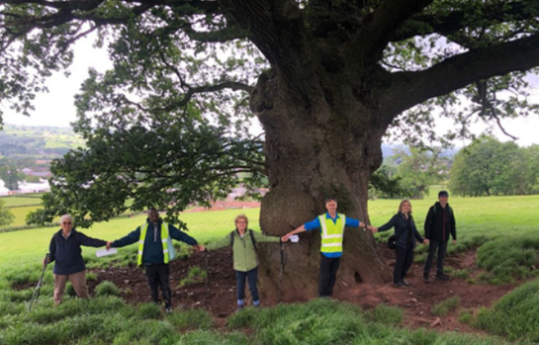  Photo: Treescapes walk as part of Hay Festival Wayfaring Walks | 1 Treescapes Situation Analysis.  1 draft Treescapes Action Plan.
Geo-spatial data and evidence building  The National Park Authority continues to look at ways to consolidate its GIS capabilities and support Officers to access the most up to date geo-spatial biodiversity data, for informing projects and programmes, as well as developing more efficient ways of recording habitat-based outputs on the ground.  For example:  Creation of GIS project spaces for Ffermio Bro and Manor Penderyn project, allowing in the case of Ffermio bro for potential projects to be ecologically screened prior to site visits.  Survey Plot Maps for the peatland survey volunteers and work with Peatland Officer to establish ways of recording total hectarages of peatland subject under restoration via the various restoration techniques.  Wildfire mapping, employing relevant data sets and mapping historic fires, to help identify areas of risk and help prioritise fire break requirements and other fire management techniques.  Development of Field reporting Apps to help record biodiversity project outputs undertaken through LPfN and Bannau Brycheiniog National Park, to help demonstrate distribution and scale of activity underway (and not previously recorded in GIS format).  Bannau Brycheiniog National Park continues to engage with opportunities around use of remote sensing, drone technology and new GIS-based decision support tools including the Living Wales platform, and Earth Observatory.  Working with Landscape Matters, an updated Landscape Character Assessment for the Park has been undertaken. With further recent work to update the Landscape Framework with reference to LANDMAP layers and complete an evaluation for strength of character and condition for the Park. Staff from different teams have had the opportunity to receive training in landscape condition assessment and participate in team field days. | Peatland restoration on-the-ground works GIS-maps.  Manor Pendery and Ffermio bro GIS-project spaces.  Wildlife risk maps & wildfire field response App for Wardens.  Revised Landscape Character Assessment.
NRAP Objective 6: Put in place a framework of governance and support for delivery
Ensure governance for biodiversity within Bannau Brycheiniog National Park.
Examples | Measures and/or indicators monitored
A Bannau Brycheiniog National Park Chief Executive, Executive Board and Authority Members are all in place and responsible for ensuring biodiversity action is planned and taken across the Authority.  The Park’s National Park Management Plan (Y Bannau), Local Nature Recovery Action Plan and Corporate Planning process, together guide nature recovery within the Park. | Executive Board and plans in place.
Consideration of biodiversity during National Park Authority Projects and Procurement processes.  General ways biodiversity is considered: The legal purpose of National Park Authority is to conserve and enhance the natural beauty, wildlife and cultural heritage of their National Park. One of the 5 Missions of Bannau Brycheiniog National Park is Nature (with Water, Climate, People and Place). These Missions have been adopted as part of the Bannau Brycheiniog National Park’s ongoing Management Plan, Dyfodol Y Bannau (2023 – 2028) and Nature includes Biodiversity as a value.  Each of the core values is considered when assessing the suitability of proposed projects and the appointment of contractors during procurement of goods and services. The weighting of each will vary depending on the nature of the project or goods or services required but they are a compulsory consideration. Where a project is not directly related to Biodiversity it will still be a consideration in terms of potential impact and control measures. | Projects:  Number of projects between 2023-2025 - 22  Number of projects specifically focussed on Nature (including Biodiversity) - 10  Percentage of projects focused on Nature (including Biodiversity) – 45%  (data from Finance Team)
Provide capacity for biodiversity.
Examples | Measures and/or indicators monitored
Bannau Brycheiniog National Park continues to have specialist Planning Ecologists and non-Planning Ecologists whose expertise can be drawn upon both internally and externally. See NRAP Objective 1 for more details. | See NRAP Objective 1.
Volunteers are a significant part of the Bannau Brycheiniog National Park team, and volunteer engagement in biodiversity projects is encouraged and supported by the National Park Authority, led by a Volunteer Development Officer.  Volunteers support biodiversity activities across Bannau Brycheiniog National Park, perhaps notably the peat survey and peat restoration projects which have been continuing successfully. Volunteers work in groups between March - October to undertake surveys to record peat depth and vegetation using a peatland recording App. There are also opportunities for volunteers to support practical peat restoration work, generally over winter, including spreading heather and Molinia brash, laying coir and jute matting, gully blocking, and dam building. Other examples of volunteer activities include support with pine marten nest box monitoring project, annual Red Grouse monitoring, Warden led volunteer groups.  The Volunteer Development Officer has supported access to biodiversity-related training for volunteers, to support and enhance the work they do. | Volunteer hours maintained by National Park Authority Volunteer Coordinator.
Joint working and integration of biodiversity goals across different disciplines is supported across the Authority’s remit. For example, objectives and actions to promote understanding of the interaction between cultural and natural ecosystems, supporting and informing sustainable strategies for green recovery and climate change mitigation have been incorporated within the Partnership based Bannau Brycheiniog National Park Historic Environment Action Plan.  Biodiversity is not just the Nature Recovery Team’s field, and cross discipline working is important for providing the resource, knowledge and on the area-based relationships required to advance nature recovery goals. The Wardens, Communities, Education, Heritage, Fforest Fawr UNESCO Global Geopark teams and Visitor Services work with school children, local communities, visitors and educational groups to support biodiversity engagement and deliver various initiatives which have a biodiversity component at their core.  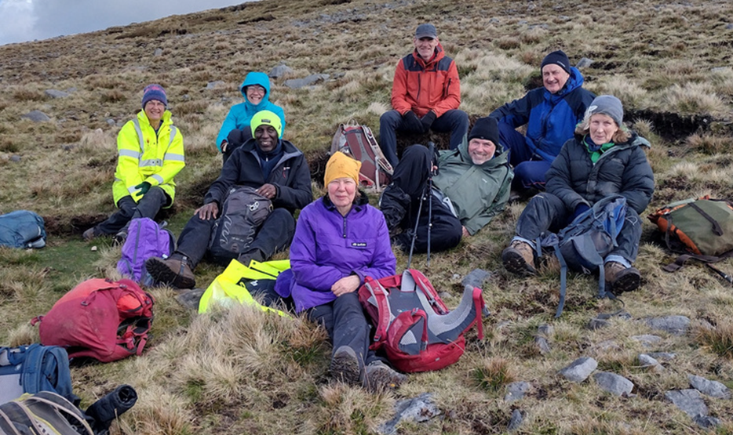Photo: Peatland volunteers  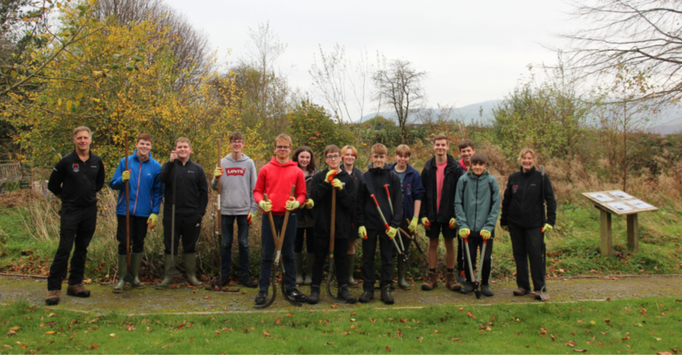  Photo: Youth Warden Scheme participants, coordinated by Wardens and Education Teams | Historic Environment Plan monitoring including biodiversity measures.  Veteran Tree Volunteer Survey group established.  See Highlights section of report and Appendix 1 for further details.
Support biodiversity action through funding and/or partnerships.
Examples | Measures and/or indicators monitored
Bannau Brycheiniog National Park engages with and supports various local and national partnerships as part of its programmes and projects delivery, as already mentioned within the Report.  Brecon Beacons Local Nature Partnership  Bannau Brycheiniog National Park is a member of, and provides secretariat to, the Local Nature Partnership. It hosts a Local Nature Partnership Projects Officer and LNP Coordinator (delivered as part of a wider role), currently funded by Welsh Government Local Places for Nature Funding. Who support the work of the Local Nature Partnership (and its 30+ members) in planning and delivering NRAP goals.  Photo: Lauch of Brecon Gateway Walks leaflet, funded by Welsh Government Local Places for Nature programme | Lead role within variety of other Partnerships, for example, Usk Catchment Partnership, Mynydd Iach Penderyn Partnership, research-based partnerships.  Active Local Nature Partnership with 50+ member organisations.
Bannau Brycheiniog Grant award programmes  The Sustainable Development Fund (SDF) directly supports biodiversity-based projects and supports local communities to take action for biodiversity.  Thanks to Sustainable Landscapes Sustainable Partnerships funding this period, Bannau Brycheiniog National Park has administered Communities Working for Nature Recovery grants and Landowners Working for Nature Grants, with awards of up to £5,000 and targeting community groups and landowners who want to undertake practical and positive local nature recovery projects.  These have complemented other community and landowner hedgerow laying grants offered through the Local Places for Nature programme. | Number of SDF/other grant awards supporting biodiversity outcomes.
Review of S6 duty
- Highlight here key issues regarding the operation of the s6 duty in your organisation, and the change this has engendered in delivery of biodiversity action, which should then be reflected in your section 6 plan
- If the review is not taking place at this point, the report should note how and when this will be conducted and how the review will be incorporated into the s6 plan.
The review of the Section 6 duty will be undertaken as part of the National Park Authority’s Corporate Plan and Future Bannau action planning process. The Authority’s ambition is to establish an integrated reporting and review mechanism for the NPMP, WBFGA, Section 6/NRAP and Corporate Plan.
Since the last report, a joined-up monitoring and evidence gathering system (working across the Authority’s plans and activities) remains an area where there is work to do. The development of the new National Park Management Plan provides an opportunity to align planning, monitoring, and reporting mechanisms across the Authority’s work (alongside the development of measurable outcomes and clear indicators). This will enhance future Section 6 reports and help to more routinely demonstrate how the many biodiversity activities are amassing and impacting on nature recovery goals, within the National Park.

Appendix 1 – Examples of biodiversity related actions undertaken by the Brecon Beacons National Park Authority,
Jan 2023- Dec 2025

Available on request

Interferometric Synthetic Aperture Radar
A Review of “a Future with Nature at its Heart, A Nature Recovery Action Plan for the Brecon Beacons National Park 2019-2024. Nicky Davies, Bannau Brycheiniog National Park Ecologist. March 2023.
Role are Full Time, unless otherwise stated.

