
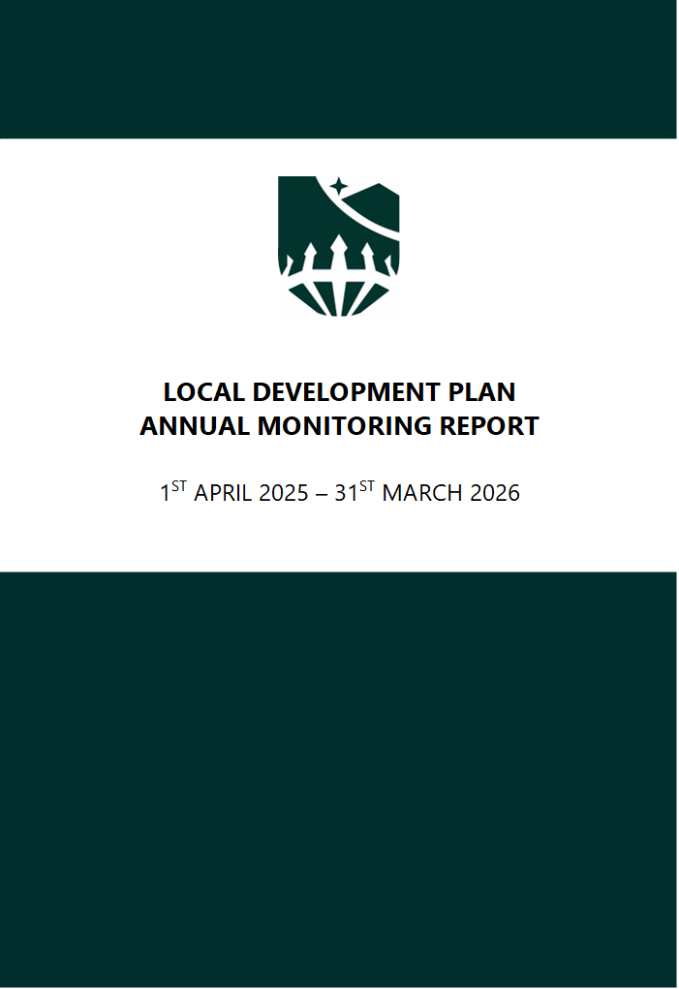
Table of Contents
Introduction 4
Sustainability Monitoring 7
Strategy Monitoring 8
Delivering Housing 9
Figure 1 – Completions relative to LDP Annual Average Requirement 9
Figure 2 – Number of dwellings for which planning permission has been granted 11
Figure 3 – Number of units granted and completed in each settlement tier 14
Figure 4 – Number of dwellings granted consent on mixed use sites 18
Figure 5 – All applications granted planning consent to achieve a density of 30 dwellings per hectare 19
Figure 6 – Affordable Housing percentage target 21
Figure 7 – Number of affordable dwellings granted consent 22
Figure 8 – Number of affordable dwellings completed 24
Figure 9 – Number of market dwellings coming forward on sites of 3 dwellings or more 26
Figure 10 – Number of affordable windfall dwellings 28
Figure 11 – Number of Affordable dwellings on Exception Sites 29
Figure 12 – Occupation of the allocated Gypsy and Traveller site 30
Figure 13 – Supplementary Planning Guidance 30
Economic Wellbeing 31
Figure 14 – Development of Employment Land 31
Figure 15 – Loss of Employment Land 32
Figure 16 – Employment development in Sennybridge and Defynnog 34
Figure 17 – Employment development in Hay-On-Wye 35
Figure 18 – Supplementary Planning Guidance 36
Policy Monitoring 37
Environmental Protection 37
Figure 19 – Land in the Countryside lost to development by way of departure from CYD LP1 37
Figure 20 – Development with an adverse impact on Historic Landscape Designations 38
Figure 21 – Development with an adverse impact on designated sites for nature conservation 39
Figure 22 – Development with an adverse impact on designated sites for heritage and building conservation. 40
Figure 23 – Number of Conservation Areas with up-to-date assessments 41
Figure 24 – Supplementary Planning Guidance 42
Climate Change, Sustainable Design and Renewable Energy 43
Figure 25 – Development in C1 and C2 flood areas not meeting Technical Advice Note 15 tests 43
Figure 26 – Planning consents contrary to advice of Natural Resources Wales and Dŵr Cymru Welsh Water regarding water quality/quantity 44
Figure 27 – Number of applications which consider climate change adaptation techniques within Design and Access Statements 45
Figure 28 – Number of applications for larger developments that fail to provide 20% of their energy from low or zero carbon resources 46
Figure 29 – Development of renewable energy schemes 47
Figure 30 – Permitted and installed capacity (MW) of renewable electricity and heat projects 49
Figure 31 – Supplementary Planning Guidance 50
Retail 51
Figure 32 – Annual vacancy rates of the Town Centres 51
Sustainable Tourism 53
Figure 33 – Number of new or improved tourism facilities 53
Sustainable Communities 56
Figure 34 – Number of applications approved resulting in the loss of community facilities 56
Infrastructure 57
Figure 35 – Amount of new development providing SUDS (Sustainable Urban Drainage Systems) 57
Waste 58
Figure 36 – Number of vacant units within the identified B Class sites suitable to accommodate a local waste facility 58
Figure 37 – Number of new licensed waste management facilities permitted 60
Minerals 61
Figure 38 – Number of consents for permanent, sterilising development within a minerals safeguarding area 61
Site Monitoring 62
Figure 39 62
Appendices 65
Appendix 1 – Graph and table of housebuilding completions against the LDP Annual Average Requirement 1
Appendix 2 – Additional Sustainability Assessment Indicators 1
Table 1 – Knowledge of Welsh Language within the National Park 12

Introduction
The National Park Authority is required by the Welsh Government to produce and submit an Annual Monitoring Report by 31st October each year following the adoption of the Local Development Plan. The report is fundamental in assessing the progress of the Local Development Plan in implementing the policies contained within the Plan and allows the National Park Authority the opportunity to assess the Policies against the most up-to-date information available. The Annual Monitoring Report also includes the results of the Strategic Environmental Assessment/Sustainability Appraisal (Appendix 2).
The monitoring exercise can assist the National Park Authority to:-
- Identify where certain policies are not being successful in delivering their intended objectives;
- Identify gaps in the evidence base, perhaps through a change legislation or national policy, which need to be addressed and reflected in the Local Development Plan;
- Identify areas of success which could be used as an example for change throughout the Local Development Plan;
- State the intended actions that the National Park Authority will take in rectifying any issues to ensure the successful implementation of the policy or any revision that needs to take place.
The National Park Authority has constructed a set of targets and indicators which act as a benchmark against which performance can be measured. Targets may relate to the achievement of certain levels of development and may be set annually or at an interim point within the Plan period. The target for the whole of the Plan is to achieve the implementation of the Local Development Plan Strategy.
The indicators and targets set out in the Monitoring Framework of the Local Development Plan also give trigger points to indicate if one part of the Plan is not achieving the desired outcomes. If these triggers are ‘activated’ then the Annual Monitoring Report will consider the necessary action which is required as a result. There are several outcomes which could be actioned by the National Park Authority in this event; these will depend on both the level to which the target appears not to have been met and the criticalness of the development to the achievement of the Local Development Plan Strategy. Contextual indicators will also be used in the Annual Monitoring Report to evaluate if it is the Plan which is not achieving the targets or if there are external factors (such as the economy or changes in funding sources etc.) which are contributing and therefore outside of the planning system’s control.
The following options are available to the National Park Authority in association with each of the indicators and their triggers. The Annual Monitoring Report will assess the severity of the situation associated with each indicator and recommend an appropriate response:
- Continue Monitoring
- Officer/Member Training Required
- Supplementary Planning Guidance/Development Briefs Required
- Policy Research
- Policy Review
- Plan/Strategy Review
As part of the Annual Monitoring Report process, the National Park Authority will also include an update on the development of allocated sites. This will highlight what activity has taken place on the site in any given year including the preparation of studies or the progression of development. If a site is not being progressed as anticipated, this will be interpreted as a trigger and appropriate action (see above) will be taken by the National Park Authority if needed.
The requirements of several of the strategic and policy indicators were completed during the first monitoring phase of the Local Development Plan, namely the occupation of the allocated Gypsy and Traveller site and the development of numerous Supplementary Planning Guidance notes. During the second phase it was recommended that monitoring ceased in relation to the number of applications for larger developments that fail to provide 20% of their energy from low or zero carbon resources due to this issue being a matter for Part L of the Building Regulations.
Notwithstanding this, many of the strategic and policy indicators, as required by the Local Development Plan Monitoring Framework, will continue to be monitored as detailed in the tables marked green and yellow below. Of these, there is a small number that require some additional work in the form of policy research as well as Officer/Member training and Supplementary Planning Guidance.
On 26 March 2020, the Minister for Housing and Local Government wrote to the National Park Authority advising the Welsh Government’s five-year housing land supply policy was to be replaced and that the housing trajectory, as set out in the adopted LDP (Local Development Plan), would be the basis for monitoring the delivery of development plan housing requirements as part of LDP Annual Monitoring Reports (AMRs).
The Development Plans Manual (Edition 3) provides additional guidance on the process of monitoring. A graph and table of completions against the Annual Average Requirement is now included in Appendix 1.
Other key contextual changes include:
- A change to the ‘Development Plan,’ with Future Wales: the national plan 2040 having been published in 2021;
- The establishment of Corporate Joint Committees as a new tier of regional government in Wales with responsibility for preparing ‘Strategic Development Plans;’
- Natural Resources Wales publishing the second State of Natural Resources Report in 2025 and Area Statements in 2020;
- Publication of the ‘State of the Park Report’ in 2020;
- New environmental evidence published in Jan 2021; Natural Resources Wales’ Compliance Assessment of Welsh River SACs (Special Areas of Conservation) against Phosphorus Targets and associated practice guidance issued by Natural Resources Wales having a significant bearing on the scope for development in much of the National Park (Evidence Report 489); A new report was published in January 2024 that compliments the previous evidence which looks at the compliance against seven additional water quality targets including ammonia (Evidence Report 729).
- Updated planning guidance (version 5.1) was published by NRW on the 9 February 2026;
- Confirmation that the Brecon Beacons Local Development Plan 2007 – 2022 (Adopted 2013) retains ‘Development Plan’ status beyond the plan period until such time a decision is taken to abandon it.
- Preparation of LDP2 (Local Development Plan 2) was ‘paused’ from 28th May 2021, mainly in response to the issues presented by NRW (Natural Resources Wales) Evidence Report 489.
- The adoption of a new Management Plan for the National Park area Dyfodol Y Bannau (Y Bannau: The future 2023-2028 which defines the agreed strategic priorities for the National Park.
- The agreement to formally withdraw the First Replacement Brecon Beacons National Park Local Development Plan (2018 – 2033) on the 7 June 2024 and to restart the replacement process.
- The agreement to consult on the draft Delivery Agreement (from 1st May until 26th June 2025) for the preparation of the Local Development Plan.

Sustainability Monitoring
The Strategic Environmental Assessment directive requires that the significant environmental effects of implementing a plan are monitored so that the appropriate remedial actions can be taken if required.
The Sustainability Appraisal of the Local Development Plan identified no significant adverse effects on the objectives; however, it identified the following significant positive effects which require monitoring.
- Climate Change Adaptation (SA1) and Greenhouse Gas Reduction (SA2) related to Policies SP4: ‘Climate Change’ and SP11: ‘Sustainable Design’;
- Water Resources (SA5) through the policy on Water Quality (Policy 10);
- Biodiversity (SA8) in relation to SP1 National Park Policy and SP3 Environmental Protection, including its supporting policy on Biodiversity and Development (Policy 6);
- Cultural Heritage (SA9) in relation to SP1 (National Park Policy) and SP3 Environmental Protection, including its supporting policy on Areas of Archaeological Evaluation (Policy 22).
- Landscape SA11 in relation to SP1 (National Park Policy) and SP3 Environmental Protection, including its supporting policies Trees and Development (Policy 8) and Light Pollution (Policy 6)
- Natural Resources and Infrastructure (SA12) through policies on Sustainable Design (SP11), Sustainable Infrastructure (SP16), Waste (SP6) and the recycling of minerals (Policy 67)
- Population (SA14) in relation to the Spatial Distribution of Development (SP10), National Park policy (SP1) and policies relating to housing (SP5), affordable housing (SP6), economic wellbeing (SP12) and Sustainable communities (SP15); and
- Economy (SA17) in relation to National Park policy (SP1) and polices relating to economic wellbeing (SP12) and retail (SP13).
The Local Development Plan adopted Monitoring framework set out below addresses some of the monitoring requirements for the SA/SEA. Additional indicators are provided within the SA (Sustainability Appraisal) to ensure that all significant effects in the SA can be monitored. These, where relevant and where data is available at National Park level, are provided at Appendix 2.

Strategy Monitoring
Key:
Action required
Complete
Continue Monitoring
Policy Research / SPG (Supplementary Planning Guidance) / Officer and Member Training
Cease Monitoring

Monitoring Period | Date
First | 17 December 2013 – 31 March 2015
Second | 1 April 2015 – 31 March 2016
Third | 1 April 2016 – 31 March 2017
Fourth | 1 April 2017 – 31 March 2018
Fifth | 1 April 2018 – 31 March 2019
Sixth | 1 April 2019 – 31 March 2020
Seventh | 1 April 2020 – 31 March 2021
Eighth | 1 April 2021 – 31 March 2022
Ninth | 1 April 2022 – 31 March 2023
Tenth | 1 April 2023 – 31 March 2024
Eleventh | 1 April 2024 – 31 March 2025
Twelfth | 1 April 2025 – 31 March 2026

Delivering Housing

Figure 1 – Completions relative to LDP Annual Average Requirement

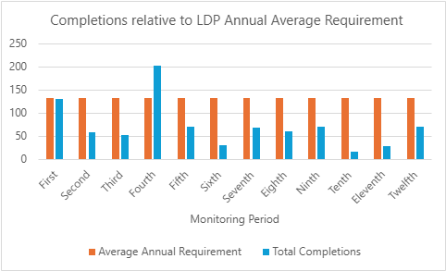

Monitoring Period | Average Annual Requirement | Total Completions | Land Supply
First | 133 | 130 | 5.5
Second | 133 | 58 | 5
Third | 133 | 52 | 4.8
Fourth | 133 | 203 | 3.9
Fifth | 133 | 69 | 2.1
Sixth | 133 | 30 | 2.7
Seventh | 133 | 67 | 2.7
Eighth | 133 | 59 | 2.7
Ninth | 133 | 69 | 1.3
Tenth | 133 | 15 | 1.3
Eleventh | 133 | 28 | 1.2
Twelfth | 133 | 69 | 0.8

Comments:
During the twelfth monitoring period (1st April 2025 to 31st March 2026), monitoring shows completions have not kept pace with the Annual Average Requirement of the LDP (See table in Appendix 1). Total completions are 69 against an Annual Average Requirement of 133.
The 2025-2026 Housing Land Availability returned a figure of 0.8 years – 4.2 years below the previously recommended ‘threshold’* of 5 years, although this is calculated against a higher annual requirement, this year calculated as 289 (see below).
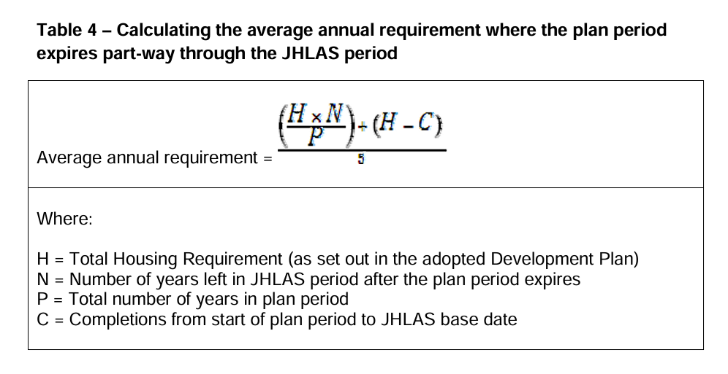H – 1990; N – 5; P – 15; C – 1207.
H x N = 9950 / P = 663 + H 1990 - C 1207 = 783 = 1446 /5 = 289.
Recommendation:
In accordance with the Development Plans Manual Edition 3, housing delivery is now monitored against the Annual Average Requirement of the LDP. A new graph is included in Appendix 1.
*Note the twelfth monitoring period is more than two full years beyond the Plan period, so there is no agreed annual requirement. However, it has been considered appropriate to continue reporting against the annual figure from the plan period for information purposes.
Delivery of this target remains constrained by the evidence published by Natural Resources Wales in January 2021 - the Compliance Assessment of Welsh River SACs [Special Areas of Conservation] against Phosphorus Targets (Evidence Report 489) – along with NRW’s associated advice to Local Planning Authorities (most-recently updated in February 2026); this has had a significant bearing on the scope for new residential development in much of the National Park. An update from NRW in 2024 showed a small improvement, with 50% of water bodies in SAC rivers now meeting the targets, up from 39% in 2021. The assessment in 2025 included 122 water bodies across Wales's nine SAC rivers, an increase from the 2021 report. Of the water bodies assessed in both reports, 17 improved, while five saw a decrease in compliance.
NRW have undertaken a Review of Permits across the SAC catchments for all Wastewater Treatment Works (WwTWs) that have daily flows of more than 20 cubic metres. Phosphate limits have been imposed, and this has enabled capacity for new residential development connecting to some WwTWs; however, this is a finite and limited capacity for the short-term and wider measures to improve water quality and restore the health of our rivers are still required.
The Welsh Government has released a Nutrient Budget Calculator to help developers and planning authorities assess the phosphorus and nitrogen impacts of new developments, particularly within Special Areas of Conservation (SAC) river catchments like the Wye, Usk, and Tywi. This calculator is crucial for ensuring nutrient neutrality, meaning new development doesn't increase nutrient pollution, as many Welsh river SACs are currently failing water quality targets for nutrients. (Nutrient budget calculator | GOV.WALES).
The National Park Authority is reviewing the calculator and related guidance, which includes revised phosphate targets from Natural Resources Wales reflecting the damaging effects of excess nutrients on water ecosystems. This tool, alongside guidance from Natural Resources Wales on nutrient neutrality requirements, will support planning decisions and help determine necessary mitigation measures for developments impacting these sensitive river environments.
The National Park Authority published a Nutrient Statement in December 2024: Nutrient-Statement-December-2024-.pdf and has worked together with local planning authorities in south west Wales to commission and publish a Marine and Estuarine dissolved inorganic nitrogen (DIN) Mitigation Strategy in affected Marine SAC catchments Report Marine and Estuarine DIN Mitigation Strategy 2025-11-20
Work continues with the Usk Catchment Partnership, which has published a Nutrient Management Plan Usk-NMP_Final.pdf and evidence portal River Usk Nutrient Management Plan and the Authority is working towards a bid for National Lottery finding for a major ‘Landscape Connections’ project.
The impact of water quality on the delivery of new development is significant. Since 2021 it has become apparent that annual completions have fallen significantly and are likely to continue to fall below those anticipated by the Local Development Plan until such time as water quality is such that it can support and not hinder the pace of recovery of designated features to favourable status.
Status | Action required

Figure 2 – Number of dwellings for which planning permission has been granted
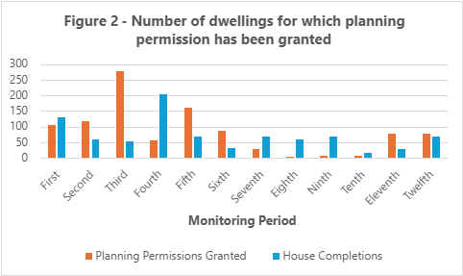

Monitoring Period | Planning Permissions Granted | House Completions
First | 106 | 130
Second | 117 | 58
Third | 276 | 52
Fourth | 57 | 203
Fifth | 161 | 69
Sixth | 86 | 30
Seventh | 29 | 67
Eighth | 2 | 59
Ninth | 5 | 69
Tenth | 6 | 15
Eleventh | 77 | 28
Twelfth | 76 | 69

Comments:
Planning permission has been granted for 76 new homes with 69 homes having been completed in Brecon (28), Gilwern (32) and on other small sites across the National Park (9).
Recommendations:
The annual indicator shows that permission granted for new homes has not keeping pace with the ambitious level of hosing growth set as the Plan’s housing requirement. Further research and investigation is required on the reasons for this, in particular around viability challenges (including build cost), on whether local businesses creating jobs are able to bare wages sufficient for employees to purchase homes in the National Park and on a pathway to ensuring water quality in the catchments of riverine Special Areas of Conservation in the National Park is sufficient to bring all SAC-designated features back into Favourable Condition. Engaging with regional development viability, housing market and housing needs work will also be important. Sub-national 2022-based population and household projections for the National Park are long overdue; the delay having meant that they did not influence the most recent iteration of the Local Housing Market Assessments.
The National Park Authority engages with Powys County Council through regular update meetings on its PDP (programme delivery plan), which is the annual plan each Local Authority submits to Welsh Government setting out all social housing schemes seeking Social Housing Grant (SHG) funding.
The Authority encouraged that Natural Resources Wales is embarking on the process of preparing Catchment Nutrient Recovery Plans, which will set out trajectories towards meeting water quality targets with levels of certainty assigned to measures bringing about the change.
The latest relevant Local Housing Market Assessments (LHMA) are:
- Powys Replacement Local Development Plan (LDP) (2022-2037) Housing Need – Local Housing Market Assessment Background paper (May 2024)
- Monmouthshire County Council – Local Housing Market Assessment Refresh 2022-2037
- Carmarthenshire Revised Local Development Plan (2018-2033) Position Statement Local Housing Market Assessment (April 2024)
- Merthyr Tydfil County Borough Council Local Housing Market Assessment 2022 – 2037 (April 2024)
- Rhondda Cynon Taf Local Housing Market Assessment (LHMA) – 2023-2028 Draft Findings January 2024
- Torfaen Local Housing Market Assessment 2023. Signed off by Welsh Government April 2025.
- Blaenau Gwent County Borough Council – Local Housing Market Assessment Report, March 2024
Status | Action required

Figure 3 – Number of units granted and completed in each settlement tier
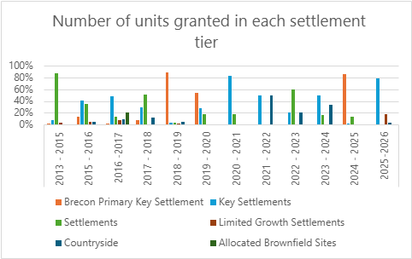

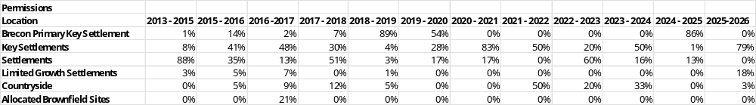

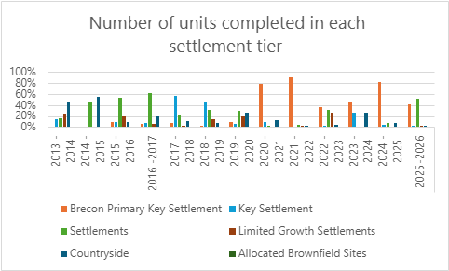

Completions
Year | Total number of units | % within Brecon Primary Settlement (number) | % within Key Settlement  (number) | % within Settlement (number) | % within Allocated Brownfield (number)
2013/14 | 64 | 0 (0) | 0 (0) | 45 (29) | 0 (0)
2014/15 | 45 | 0 (0) | 14 (6) | 16 (7) | 0 (0)
2015/16 | 58 | 9 (5) | 9 (5) | 54 (31) | 0 (0)
2016/17 | 52 | 6 (3) | 8 (4) | 61 (32) | 0 (0)
2017/18 | 203 | 7 (14) | 56 (114) | 23 (47) | 0 (0)
2018/19 | 89 | 2 (2) | 47 (41) | 31 (27) | 0 (0)
2019/20 | 30 | 10 (3) | 6.5 (2) | 30 (9) | 0 (0)
2020/21 | 67 | 78 (52) | 9 (6) | 1 (1) | 0 (0)
2021/22 | 59 | 90 (53) | 0 (0) | 3 (5) | 0 (0)
2022/23 | 69 | 36 (25) | 1 (1) | 32 (22) | 0 (0)
2023/24 | 15 | 46 (7) | 26 (4) | 0 (0) | 0 (0)
2024/25 | 28 | 82 (23) | 4 (1) | 2 (7) | 0 (0)
2025/26 | 69 | 42 (29) | 1 (1) | 52 (36) | 0 (0)
TOTAL | 848 | 26% | 22% | 30% | 0%

Comments:
Permissions:
One of the objectives of the LDP is to encourage development in sustainable locations near facilities and services therefore minimising the need to travel, whilst also respecting the National Park purposes and special qualities. It is therefore encouraging to see the continuation of most residential units granted planning permission being located within either the Primary Key Settlement of Brecon, the Key Settlements of Crickhowell, Hay-On-Wye, Talgarth and Sennybridge and Defynnog along with the Level 3 Settlements.
This is a three-year indicator with an assessment trigger of more than 50% of dwellings granted planning permission being outside the Primary Key and Key Settlements.
Monitoring period |  | Number of housing units granted planning permission.
Tenth | 1st April 2023 - 31st March 2024 | 6
Eleventh | 1st April 2024 - 31st March 2025 | 77
Twelfth | 1st April 2025 - 31st March 2026 | 76
3-year total |  | 159

Given the relatively low overall number of units granted planning permission, this indicator has been met through a single permission granted during the eleventh monitoring period for 66 units on the Roy Hatton site in Brecon Primary Key Settlement, 43 units in Talgarth and 16 in Hay on Wye.
Completions:
This indicator requires the following locational proportion of completions:
- Primary Key Settlement – 20%
- Key Settlements – 27%
- Settlements – 28%
- Allocated Brownfield Sites – 0%

The percentage (and number) of completions per settlement tier for the twelfth monitoring period is set out in the table below:
Settlement hierarchy | Completions | % rounded to nearest whole
Primary Key Settlement Brecon | 29 | 42
Key Settlements | 1 | 1
Settlement | 36 | 52
Limited Growth Settlement | 2 | 3
Countryside | 1 | 1
Total | 69

The monitoring framework states that the assessment shall be triggered for this indicator if less than 50% of dwelling completions occur within the Primary Key Settlement and Key Settlements over a 3-year period.
Completions in the Primary Key Settlement of Brecon, and the key settlements of Crickhowell, Talgarth, Hay-on-Waye and Sennybridge and Defynnog have dropped below the 50% target this year due to development in Govilon, however, remain above the target level across the 3-year monitoring period.
Recommendations:
Whilst the period for this indicator has been completed, it is necessary to continue monitoring the indicator.
Status | Continue Monitoring

Figure 4 – Number of dwellings granted consent on mixed-use sites

Comments:
Full planning permission granted on appeal for 119 dwellings at Cerrigcochion Road, Penlan, Brecon is now substantially complete.
Outline planning permission has been granted for an indicative number of 68 dwellings and employment facilities at the Former Army Camp, Cwrt-Y-Gollen (CS66).
Supplementary Planning Guidance, in the form of a development brief was approved in 2019 for CS111 – Former Mid Wales Hospital, Talgarth (125).
Recommendation:
There is no assessment trigger for this indicator. Accordingly, this will be monitored over the remainder of the plan period.
Status | Continue Monitoring

Figure 5 – All applications granted planning consent to achieve a density of 30 dwellings per hectare

Comment:
Policy 61 of the Local Development Plan relates to dwelling density and states that:
“All residential development will be required to be developed at a minimum density of 30 dwellings to the hectare, where this is compatible with the existing character of the area.
Only where it is proven that this density cannot be achieved due to the incorporation of measures to improve the sustainability of the scheme, which cannot be located on land outside of the allocation, will levels less than the minimum target be permissible.”
There is some flexibility in this policy that would allow development to be approved at a level of density below 30 dwellings per hectare, such as the character of the surrounding area. Furthermore, there have been instances where a lower level of density has been agreed due to abnormal conditions on site – topography and access constraints, for example.
Recommendation:
The indicator suggests that this policy is not being implemented as required. However, it must be noted that there is flexibility within the policy that allows development to take place at a density below 30 dwellings per hectare.
In the 2024/25 AMR it appears that the number of units on sites rather than the number of planning permissions granted (rather than units) has been included in the figures. The ‘66’ figurer relating to a single permission for 66 units rather than the grant of 66 planning permissions.
Status | Policy Research

Figure 6 – Affordable Housing percentage target

Affordable Housing percentage target
Monitoring Period | The Land Registry House Price Index (Merthyr Tydfil) (%)
First | 13% increase
Second | 1.75% decrease
Third | 1.4% increase
Fourth | 1.3% increase
Fifth | 0.2% increase
Sixth | 5.23% increase
Seventh | 11.1% decrease
Eighth | 22.7% increase
Ninth | 22.7% increase
Tenth | 11.6% decrease
Eleventh | 2.5% decrease
Twelfth | 3.9% decrease

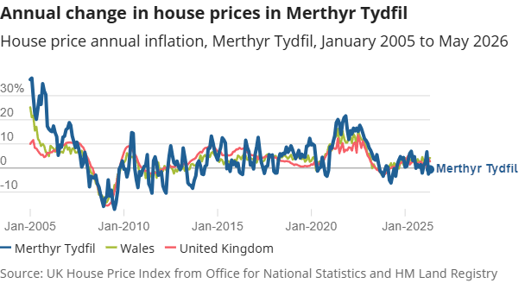
Comment:
The assessment trigger for this indicator is a 2.5% change in house prices in the Heads of the Valley sub-market area and a 5% change across the rest of the National Park area.
Recommendation:
Given that the Land Registry data, together with the Development Appraisal Toolkit data, suggest a significant overall increase in house prices in the Heads of the Valleys area, it will be necessary for the Authority to consider additional viability testing with a view to modifying the Affordable Housing contribution targets (if appropriate) as part of the development of the replacement Local Development Plan.
Status | Policy Research

Figure 7 – Number of affordable dwellings granted consent

Monitoring Period | No. AH units granted planning permission | % of total residential units granted planning permission | Against performance indicator of 47 AH permissions p/annum (+/- 30%)
First | 24 | 17% | -23
Second | 45 | 38% | -2
Third | 63 | 23% | +16
Fourth | 9 | 12% | -38
Fifth | 21 | 13% | -26
Sixth | 55 | 19% | +8
Seventh | 19 | 66% | -28
Eighth | 0 | 0% | -47
Ninth | 0 | 0% | -47
Tenth | 0 | 0% | -47
Eleventh | 66 | 86% | +19
Twelfth | 59 | 77% | +12

Comment:
The target for this indicator is 47 Affordable Housing dwellings to be granted planning permission per annum (+/- 30%). There is also an assessment trigger of fewer than 38 Affordable Housing dwellings being provided annually for 3 consecutive years.
During the twelfth monitoring period planning permission was granted for 59 affordable homes on sites in Talgarth (43) and Hay on Wye (16).
It appears accessing social housing grant is increasingly important as a model for developing sites in the national park. The other large scheme or more than 10 units being the conversion of a former public house to 12 units in Pontneddfechan.
Recommendation:
This indicator is to be monitored for a further year.
Status | Continue Monitoring

Figure 8 – Number of affordable dwellings completed

Monitoring Period | No. AH Completed | AH Completions Target
First | 37 | 15
Second | 10 | 15
Third | 24 | 15
Fourth | 41 | 15
Fifth | 28 | 15
Sixth | 2 | 15
Seventh | 21 | 15
Eighth | 32 | 15
Ninth | 10 | 15
Tenth | 6 | 15
Eleventh | 1 | 15
Twelfth | 15 | 15

Comment:
The target indicator of 20 units has not been met for the past three consecutive years.
The second assessment trigger requires more than 15 Affordable Housing dwellings to be completed annually for three consecutive years. The total number of completions for affordable housing over the last 3 monitoring periods is 21 units, an average of 6.5 a year, with 15 completed in the twelfth monitoring period.
With increased numbers of units having been granted over the past two monitoring periods, in particular in Brecon and Hay on Wye, it would appear targets set out within the LDP are likely to be met in the upcoming annual monitoring reports. Continued engagement with Powys County Council’s Social Housing Programme Delivery Plan in particular, will assist with understanding issues faced by social housing providers in the National Park.
Recommendation:
The indicator will continue to be monitored.
Status | Action Required

Figure 9 – Number of market dwellings coming forward on sites of 3 dwellings or more

Monitoring Period | Number of Open Market Houses | Number of Sites | Loss of Affordable Houses
First |  |  | 13
Second | 25 | 4 | 5
Third | 23 | 4 | 19
Fourth | 0 | 0 | 0
Fifth | 119 | 1 | 23
Sixth | 5 | 1 | 2
Seventh | 10 | 2 | 2
Eighth | 0 | 0 | 0
Ninth | 0 | 0 | 0
Tenth | 0 | 0 | 0
Eleventh | 6 | 1 | 0
Twelfth | 12 | 1 | 0

Comment:
Policy 28 of the LDP seeks to enable affordable housing on sites where there is a net gain in housing at a set target level; however, provision is made within the policy to enable the level of affordable housing to be reduced below target levels because of robust evidence demonstrating target levels are not viable.
This indicator seeks to monitor the extent to which permitted residential schemes can meet target levels of affordable housing. This indicator provides information in relation to the potential gap between policy aspirations and market delivery by seeking to monitor the number of affordable housing units ‘lost’ because of viability testing.
The one site granted planning permission for the development of 3 or more open market dwellings (Former Dinas Inn, Pontneddfachan) is in an areas of the National Park where it was determined at plan making stage that affordable housing contributions would render development unviable.
Policy-level affordable housing targets will be reviewed as part of the replacement LDP preparation.
Recommendation:
The indicator will continue to be monitored.
Status | Continue Monitoring

Figure 10 – Number of affordable windfall dwellings

Comments:
The annual target of 3 windfall Affordable Housing dwellings being granted planning permission per annum has this year been met.
During the eleventh monitoring period, it is unclear why the 66 affordable extra-care unit homes permitted in Brecon on the former Roy Hatton car sales site were not recorded. During the twelfth annual monitoring period, 16 units were granted planning permission on the site of the former community centre.
Prior to the eleventh monitoring period, the small number of residential units granted planning permission, just 6 in 2023/24 and 11 in 2024/25, suggest a wider downturn / trend which may not be specific to Affordable Windfall Permissions.
Recommendations:
The indicator will continue to be monitored.
Although unfavourable market conditions are likely to be a significant factor in the development of windfall affordable housing, it must also be noted that the phosphate issue and build costs will be compounding factors against the delivery of this target.

Status | Continue Monitoring

Figure 11 – Number of Affordable dwellings on Exception Sites

Comments:
Whilst the annual target of 4 Affordable dwellings being granted planning permission on exception sites has not been met, it should be noted that this is not because of the refusal of any planning application. No ‘exception site’ applications were received during the period, which can be beyond the control of the Authority. Accordingly, given that it relates to ‘exceptional development,’ consideration will be given to whether this indicator will be monitored in the future.
See also commentary above relating to windfall affordable housing sites, market conditions and the water quality impacts..
Recommendations:
Continue monitoring but consider whether this indicator should continue to be monitored in the future.
Status | Continue Monitoring

Figure 12 – Occupation of the allocated Gypsy and Traveller site
Occupation of the allocated Gypsy and Traveller site
The allocated Gypsy and Traveller site has been developed.

Comment:

Further to the granting of planning permission on 27th March 2012 for a proposed permanent Gypsy and Traveller site the 14 pitches granted consent have been developed.

Recommendation:

The monitoring framework required this site to be occupied by 2017. The site has already been developed and occupied so no further monitoring is required.

Status | Complete.

Figure 13 – Supplementary Planning Guidance
Supplementary Planning Guidance
Supplementary Planning Guidance has been produced in relation to the following:
- Affordable Housing Strategy
- Affordable Housing SPG
- Planning Obligations Strategy
- CYD LP1: Appropriate Development in the Countryside
- Addendum to CYD LP1: Appropriate Development in the Countryside

Comment:

In line with the requirements of the Local Development Plan Monitoring Framework, Members have endorsed the above Supplementary Planning Guidance. These guidance documents take account of and address the 6 Supplementary Planning Guidance referred to in the ‘Delivering Housing’ section of the Local Development Plan Monitoring Framework.

Recommendation:

The relevant Supplementary Planning Guidance has been completed. Accordingly, no further monitoring is required.

Status | Complete.

Economic Wellbeing

Figure 14 – Development of Employment Land

Comments:
The trigger for assessment in relation to this indicator is that less than 0.5 hectares of employment land allocated is developed by 2017 and 0.75 hectares by the end of the Plan period. As referred to above, a total of 2.49 hectares of employment land has been granted planning permission for B1, B2 and B8 uses during (and now beyond) the Plan period.
In support of preparing the replacement Local Development Plan (now withdrawn), the Authority commissioned evidence in the form of a comprehensive Employment Land Review and this would need to be brought up to date when preparation of the replacement LDP again commences.
Further assessments (A Mid Wales Employment Sites and Premises Needs Assessment and Action Plan) have been prepared undertaken to inform the portfolio of the Mid Wales Growth Deal and we are aware the Cardiff Capital Region is set to commission similar studies.
Recommendations:
This indicator requires at least 0.5ha of employment land to be developed by 2017, and 0.75 hectares over the Plan period. Accordingly, the requirements of this indicator have been met.
Status | Complete.

Figure 15 – Loss of Employment Land

Monitoring Period | No. permissions | Planning applications ref: | Description | Location
First | 0
Second | 0
Third | 0
Fourth | 0
Fifth | 0
Sixth | 0
Seventh | 1 | 20/18408/FUL | Change of use from B8 to D2 (Gym) | Ffrwdgrech Industrial Estate, Brecon
Eighth | 1 | 21/19880/FUL | Change of use from B8 to D1 (Vets) | Ffrwdgrech Industrial Estate, Brecon
Ninth | 0
Tenth | 2 | 23/21967/FUL  23/22408/FUL | Change of use from B2 to Sui Generis (Police Station)  Change of use from B1 to A1 (Retail) | Ffrwdgrech Industrial Estate, Brecon  Elvicta Estate, Crickhowell
Eleventh | 0
Twelfth | 0

Comments:
None.
Recommendations:
The trigger for assessment for this indication is 1 application being granted planning permission on existing employment land for non-employment land uses. During the Plan period 4 permissions have been granted with the loss of B class units. Accordingly, this indicator will continue to be monitored and will be the subject of Policy Research.
Status | Policy Research

Figure 16 – Employment development in Sennybridge and Defynnog

Comments:
This indicator was included because of a proposed allocated employment site being withdrawn from the Local Development Plan by the landowner during the Examination. An assessment would be triggered if 1.43 ha of employment land is not granted planning permission within or beyond the Sennybridge and Defynnog settlement by 2017.
It should be noted that the Authority’s Employment Land Review identified a requirement to deliver 1.46ha of employment land for the whole National Park area up to the end of the Plan period.
One permission was granted for employment generating development within Sennybridge and Defynnog within the Eighth monitoring period, leading to 0.12ha of B8 use (Ref: 20/19074/FUL - Proposed change of use of existing yard and barn from Agricultural Use (Sui Generis) to a Mixed Use of Agriculture and B8 storage and distribution (animal feeds and bedding) and installation of a feed hopper).
Whilst not in the settlement boundary, development of the former Greystones Motel near Trecastle as 2.25Ha of B2 use was granted planning permission during the twelfth monitoring period (application reference 24/22689/FUL).
Recommendations:
The indicator will be monitored for a further year or until the monitoring target has been reached.
The matter will also be addressed through preparation of the replacement LDP.
Status | Continue Monitoring

Figure 17 – Employment development in Hay-On-Wye

Comments:
The permission granted within the seventh monitoring period comprised a change of use from 1st floor residential to business use B1. This resulted in an additional 0.0088ha of additional employment land (ref: 20/19309/FUL). The permission granted within the fifth monitoring period comprised the change of use from a former bank (A2) to part business (B1) and part residential (C3).
This indicator was included because of planning permission being granted for a community use on land allocated for employment use before the adoption of the LDP. An assessment would be triggered if 0.6 ha of employment land is not granted planning permission within or beyond the Hay-on-Wye settlement by 2017.
It should be noted that the Authority’s Employment Land Review identified a requirement to deliver 1.46ha of employment land for the whole National Park area up to the end of the Plan period.
In addition, a 4.2 ha mixed-use allocation comprising 2.4 ha of employment land is proposed to be allocated in Powys County Council’s Deposit Local Development Plan. The site is referred to as Land at Gypsy Castle Lane (Site Ref: MUA 1) is located immediately adjacent to the Hay-on-Wye settlement boundary. It is considered that the development of this site would satisfy the requirements of this indicator and during the twelfth monitoring period we commented at pre -application stage on a draft proposal for development of the site, since when a planning application has been submitted to Powys County Council.
Recommendations:
The indicator will be monitored for a further year or until the monitoring target has been reached. The matter will also be addressed as part of the replacement LDP.

Status | Continue Monitoring

Figure 18 – Supplementary Planning Guidance

Supplementary Planning Guidance
Members have endorsed the Farm Diversification Supplementary Planning Guidance for use in the determination of relevant planning applications.
Comment:
None.
Recommendation:
The relevant Supplementary Planning Guidance has been completed. Accordingly, no further monitoring is required.
Status | Complete.

Policy Monitoring

Environmental Protection

Figure 19 – Land in the Countryside lost to development by way of departure from CYD LP1

Comments:
During the eleventh monitoring period a recent application (ref: 22/21662/FUL) was approved at the planning committee for B use class employment outside of settlement boundaries and extents. This decision represents a departure from Policy CYD LP1 and Policy 36.
All development permitted in the Countryside (as defined by the LDP) during the twelfth monitoring period has been held to accord with the relevant spatial development plan policy, LDP Policy CYD LP1.
Recommendations:
It is recommended that the monitoring of this indicator continues.
Status | Continue Monitoring

Figure 20 – Development with an adverse impact on Historic Landscape Designations

Comments:
Cadw has produced a Register of 58 Landscapes of Outstanding and Special Historic Interest in Wales. Eight of these are, at least partly, within Bannau Brycheiniog National Park. Those with significant overlap include the Black Mountain and Mynydd Myddfai, the Middle Wye Valley, East Fforest Fawr and Mynydd-y-Glog, and the Middle Usk Valley.
Recommendations:
The requirement of this indicator is being met. It is, however, considered to be an important indicator and will continue to be monitored.
Status | Continue Monitoring

Figure 21 – Development with an adverse impact on designated sites for nature conservation

Comments:
Planning Policy Wales, Edition 12, sets out in Figure 13, the range of designated sites in Wales and the approach which should be taken when considering planning applications impacting on them.
During the twelfth monitoring period it is again being recorded that no development granted planning permission in the National Park has resulted in any adverse impact on any of these sites.
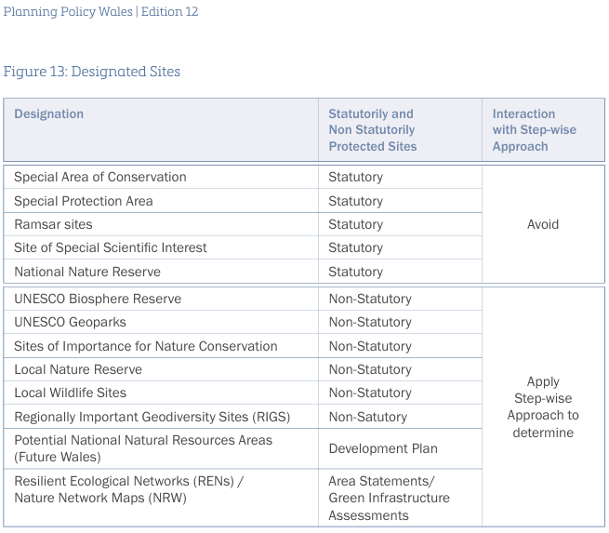
Recommendations:
The requirement of this indicator is being met. It is, however, considered to be an important indicator and will continue to be monitored, particularly considering Natural Resources Wales’ Compliance Assessment of Welsh River SACs against Phosphorus Targets (Evidence Report 489), which has a significant bearing on the scope for development in much of the National Park.
Status | Continue Monitoring

Figure 22 – Development with an adverse impact on designated sites for heritage and building conservation.

Comments
During the second monitoring period, two planning permissions were granted which would have an adverse impact on sites for heritage and building conservation (Brecon Conservation Area and Brecon Cathedral), each being considered acceptable on balance by the Authority’s Planning Committee.
Although not previously reported, during the eleventh monitoring period, development was permitted with an adverse impact on designated sites for heritage and building conservation. The proposed extra care facility on the former Roy Hatton site in Brecon was granted planning permission again the recommendation of officers, with the planning committee determining that public benefits outweighed negative heritage impact on Conservation Area.
Recommendations:
The requirement of this indicator is being met. It is, however, considered to be an important indicator and will continue to be monitored and regular member training on built heritage matters should be continued.

Status | Continue Monitoring

Figure 23 – Number of Conservation Areas with up-to-date assessments

Comments:
Following consultation, Crickhowell and Llangattock Conservation Area Appraisals were approved by the National Park Authority during the 7th Monitoring period (2020/2021).
Recommendations:
This assessment would be triggered for this indicator should the Conservation Area Assessments not be completed by the end of 2017. Appraisals have now been completed for Brecon, Hay-On-Wye, Talgarth, Crickhowell and Llangattock Conservation Areas. Accordingly, no further monitoring is required.
Status | Ceased Monitoring
Status | Completed during seventh monitoring period.

Note: Twelfth monitoring period.
Whilst all conservation areas have up to date assessments, three (3) appraisals are due to for review from September 2016 (after 10 years) and should be reviewed prior to this date.
Recommendation: That this work be considered for prioritisation during service planning for the 2027/28 financial year.

Figure 24 – Supplementary Planning Guidance

Supplementary Planning Guidance
In line with the requirements of the LDP Monitoring Framework, Members have endorsed the following Supplementary Planning Guidance for use in the determination of relevant planning applications:
- Obtrusive Lighting
- Biodiversity Audit
The proposed Supplementary Planning Guidance relating to Best Practice in Biodiversity has published and endorsed for use in the determination of relevant planning applications. The publication of this SPG was delayed, due in part to the work that has been undertaken to extend the Biodiversity Audit Supplementary Planning Guidance to include the remaining Level 2 Key Settlement at Sennybridge and Defynnog (which has also been endorsed).

Comment:
None.

Recommendation:
The relevant Supplementary Planning Guidance has been completed. Accordingly, no further monitoring is required.
Status | Complete. Biodiversity Audit Completed in 2016.

Climate Change, Sustainable Design and Renewable Energy

Figure 25 – Development in C1 and C2 flood areas not meeting Technical Advice Note 15 tests

Comments:
During this monitoring period, no planning permissions were granted in a C1 or C2 flood zone against the advice and tests contained in either the previous Technical Advice Note 15: Development and flood risk or the new Technical advice note (TAN) 15: development, flooding and coastal erosion | GOV.WALES (March 2025).
During the period covered by the fifth monitoring report, following a committee resolution to permit vulnerable development by supporting a Change of Use within a C2 flood zone, an application was called in for determination by the Welsh Ministers and was refused.
Recommendations:
We note that a replacement TAN15 (Technical Advice Note 15) was published on the 31st March 2025. The new TAN has come into immediate effect as a material consideration and applies to all planning applications. The new TAN places increased emphasis on the LDP as the mechanism for both allocating sites but also identifying flood mitigation measures and assessing risk. In addition, the new TAN takes a risk-based approach using the Flood Map for Planning to balance the likelihood of flooding events against the vulnerability of development.

Status | Continue Monitoring

Figure 26 – Planning consents contrary to advice of Natural Resources Wales and Dŵr Cymru Welsh Water regarding water quality/quantity

Comments:
During the twelfth monitoring period application 20/18876/FUL was granted planning permission against the advice of Dwr Cymru Welsh Water for the Erection of Crai Valley Eco Centre, provision of Car Parking, Landscaped Garden Area together with all other associated works. During the process amended details were submitted meaning that the wastewater would not be directed to the Wastewater Treatment Works.
Recommendations:
The requirement of this indicator is being met. It is, however, considered to be an important indicator and will continue to be monitored particularly considering Natural Resources Wales’ Compliance Assessment of Welsh River SACs against Phosphorus Targets (Evidence Report 489) and associated practice guidance, which has a significant bearing on the scope for development in much of the National Park.
Status | Continue Monitoring

Figure 27 – Number of applications which consider climate change adaptation techniques within Design and Access Statements

Comments:
None. This data is drawn from Uniform (the software system used for development management). It is unclear whether this aspect is being systematically recorded. Welsh Government guidance on Design and Access Statements explains the DAS (design and access statement) should explain the environmental sustainability strategy, how the proposals will meet or exceed sustainable building standards and how associated carbon emissions will be minimised, including how the development responds to the impact of current and projected future climate change. (https://www.gov.wales/sites/default/files/publications/2018-09/design-and-access-statements.pdf)
If a DAS is required, and one is submitted which does not meet the statutory minimum content requirements, planning applications should not be validated.
Recommendations:
The requirement of this indicator is being met. It is, however, considered to be an important indicator and will continue to be monitored.
Status | Continue Monitoring

Figure 28 – Number of applications for larger developments that fail to provide 20% of their energy from low or zero carbon resources

Number of applications for larger developments that fail to provide 20% of their energy from low or zero carbon resources
Ceased Monitoring

Comment:
This indicator arose because of the requirements of Policy SP11 (Sustainable Development) as it was originally drafted in the Deposit Local Development Plan. However, this specific requirement was removed from the policy by the Inspector during the Local Development Plan Examination on the basis that it was beyond the requirements of National Planning Policy. The indicator remains in the Monitoring Framework by error as it was not picked up during the editing process and amended by way of the Matters Arising Changes.

There is no policy in the Plan to enforce this requirement and, accordingly, it is recommended that this indicator ceases to be monitored.

Recommendation:
Cease Monitoring

Status | Ceased Monitoring

Figure 29 – Development of renewable energy schemes

Comments:
During the twelfth monitoring period, a significant solar energy installation of 1052 Ground Mounted Solar PV panels at the Brecon Carreg water bottling plant in Carmarthenshire was granted planning permission by the Authority’s planning committee.
During the 7th monitoring period, Community Energy Audits were undertaken across the National Park, alongside C02 emissions reduction analysis (November 2020) and more recently an energy only Paris Aligned Carbon Budget. The emissions reduction analysis showed just one Lower Super Output Area (New Inn 4) across the whole National Park had met the Welsh Government’s emissions reduction target of 3% per annum between 2010 and 2018. During this period emissions in one Lower Super Output Area (Goetre Fawr 1) had increased.
Furthermore, for the National Park to make its ‘fair’ contribution towards the Paris Agreement, the area-based Carbon Budget identifies a need to:
- Stay within a maximum cumulative carbon dioxide emissions budget of 1,557 thousand tonnes (ktCO2), for the period of 2020 to 2100;
- Initiate an immediate programme of CO2 mitigation to deliver annual cuts in emissions averaging 14% to deliver a Paris Agreement aligned carbon budget; and,
- Reach zero or near zero carbon no later than 2039.
The report behind the budget recommends the National Park should:
- increase sequestration of CO2 through land use, land-use change and forestry (LULUCF), for example aligning with Committee on Climate Change’s high-level ambition of tree planting, forestry yield improvements and forestry management; and.
- ensure such CO2 sequestration is also sufficient to help compensate for non-CO2 emissions within the National Park.
More recently the Authority, along with each of the other UK National Park Authorities, commissioned Small World Consulting to prepare a pathway to net zero. Each Local Authority has published a Local Area Energy Plan, which sets out high-level options to achieve decarbonisation of the energy supply.
The Welsh Government has jointly commissioned National Energy Services Operator (NESO) to prepare National (UK-wide) and Regional (i.e. national Wales-wide) spatial plans for energy generation.
Recommendations:
The requirement of this indicator is being met. It is, however, considered to be an important indicator and will continue to be monitored.
Status | Continue Monitoring

Figure 30 – Permitted and installed capacity (MW) of renewable electricity and heat projects

Comments:
The total capacity increase since monitoring began is 5.9671 Megawatts.
Recommendations:
The requirement of this indicator is being met. It is, however, considered to be an important indicator and will continue to be monitored.

Status | Continue Monitoring

Figure 31 – Supplementary Planning Guidance

Supplementary Planning Guidance
In line with the requirements of the Local Development Plan Monitoring Framework, Members have endorsed the following Supplementary Planning Guidance for use in the determination of relevant planning applications:

- Sustainable Development in the National Parks of Wales
- Small Scale Renewable Energy Developments

Comment:
None.

Recommendation:
The relevant Supplementary Planning Guidance has been completed. Accordingly, no further monitoring is required.

Status | Complete.

Retail

Figure 32 – Annual vacancy rates of the Town Centres

Monitoring Period | Brecon | Crickhowell | Hay on Wye | Talgarth
First | 9% | 6% | 2% | 8%
Second | 8% | 4% | 2% | 11%
Third | 7% | 3% | 3% | 9%
Fourth | 10% | 4% | 4% | 4%
Fifth | 11% | 8% | 7% | 4%
Sixth | 12% | 5% | 7% | 2%
Seventh | 9% | 3% | 7% | 0%
Eighth | 9% | 1% | 5% | 0%
Ninth | 6% | 1% | 7% | 4%
Tenth | 9% | 3% | 4% | 7%
Eleventh | 8% | 7% | 8% | 9%
Twelfth | 12% | 4% | 5% | 5%

Comments:
The purpose of this indicator is to address the ‘health’ of the retail centres in the National Park. Vacancy rates are monitored within defined areas of the town where there is a strategic objective to support the predominance of retail or town centre uses.

Whilst vacancy rates have dropped in Crickhowell, Hay-on-Wye and Talgarth, either through new businesses or appropriate changes of use, the vacancy rate in Brecon has increased above 10% for the first time since the sixth monitoring period. The Authority is aware of town centre highway proposals being pursued by Powys County Council, however the rise in vacancy rates require further investigation.

The Crickhowell Place Plan was published in June 2024. This plan was developed by external consultants on behalf of the National Park Authority and Crickhowell Town Council to outline a vision for the town's future over the next 15 years. It is aligned with the Dyfodol Y Bannau Management Plan and won the prestigious RTPI Cymru annual award for Plan of the Year in 2024. Additionally, a Place Plan toolkit has been created to assist Authority officers in preparing other place plans.

The Policy team will continue to work with external agencies to explore how to support our retail centres and work to develop best practices to inform the replacement Local Development Plan.

Recommendations:
This indicator will be monitored for a further year. When preparing services plans for 2027/28 , consider allocating resource to investigate and understand better, the rise in town centre vacancy rates in Brecon.

Status | Policy Research

Sustainable Tourism

Figure 33 – Number of new or improved tourism facilities

Comments:
The applications approved within the twelfth monitoring period include:
Reference | Proposal | Location
20/18876/FUL | Erection of Ysgubor 'Newydd Centre' to provide an amenity building for guests staying within the holiday accommodation (Crai Valley Eco Lodges). | Glwydcaenewydd Farm Cray LD3 8YP
24/23045/FUL | Conversion of existing stable to holiday let. | Twr Mihangel Llanvihangel Crucorney NP7 8DH
24/23010/FUL | Retrospective change of use of agricultural land to a glamping site. | Coed Hir Dol-Y-Gaer CF48 2UR
25/23505/FUL | Conversion of an existing one-bedroom equine holiday let and stable block into two, 2-bedroom holiday lets and a communal games room. | Castell Prydydd Cefn Goleu Ninfa Llanellen NP7 9LE
25/23685/FUL | Change of use of existing Chapel into Holiday Let | Penuel Chapel Cwm-Du NP8 1RT
21/20677/FUL | Use of existing Annexe as a mixed-use providing holiday accommodation in addition to existing use as Annexe. | The Annexe, Neuadd Fechan Llanbedr NP8 1SR
23/22483/FUL | Conversion of former bothy to a studio for use ancillary to the lawful use of the land as holiday accommodation. In addition, the installation of decking area to the existing caravan. | Ty-Phillip Llanbedr NP8 1SY
24/22878/FUL | Proposed conversion of existing outbuilding, 2no. yurts with kitchen/dining and ablutions facilities and associated works to provide holiday accommodation. | White House Mews Merthyr Road Llanfoist NP7 9LR
24/23245/FUL | Two proposed shepherds hut for holiday accommodation. | Ty'r Philip-Evan Farm Hillside Llangattock NP8 1LF
24/23392/FUL | Conversion of a redundant lambing shed to one bedroom holiday accommodation. | The Coach House Cynghordy Llanhamlach LD3 7EX
24/23404/FUL | Erection of holiday accommodation pods, amenity pod, and workshops, with associated decking and installation of roof-mounted solar PV panels; siting of yurt; erection of timber canopy to existing stable building, and polytunnel; installation of swimming pool; installation of roof-mounted solar PV panels. | The Farmhouse Danydarren Farm Merthyr Tydfil CF48 2HP
24/23466/FUL | Change of use of existing volunteer accommodation (granted planning permission under approval number P17739) to 2 holiday let units | Beiligwennol Libanus LD3 8NH
25/23828/FUL | The Change of use of land and buildings from overnight accommodation by school children using the facilities at the Outdoor activity centre to the use of land and buildings for overnight holiday accommodation and 3 additional holiday cottages including reconfiguration of existing car parking and enhancement to existing on-site restaurant. | Royal Oak Camp Llangorse LD3 7TR
25/23836/FUL | Conversion of One Disused Barn to Holiday Accommodation. | Dower House Forest Coal Pit NP7 7LP
25/23712/FUL | Planning application for conversion and extension of the existing toilet block to accommodate new public toilet, visitor information facilities and offices. | Toilet Block Lion Yard Brecon LD3 7BA
25/24031/FUL | Erection of a yurt on the farm adjacent to an alpaca trekking business to provide space in wet weather for the meet and greet, and introductory talks that form part of every trek. | Blaenrheon Penpont LD3 8ES
25/23851/FUL | Change of use of land for the siting of 2 shepherds huts. | Land Forming Part Of Blaencennen Gwynfe SA19 9RT

Recommendations:
The requirement of this indicator is being met. It is, however, considered to be an important indicator and will continue to be monitored.
Each and every commercial facility should be designed from the outset to be accessible to all, and it is recommended that resource be given to investigate whether the public sector equality duty is being satisfactorily upheld when determining all such applications. The nature of the development means it is important to monitor compliance with any planning conditions, ensuring development is in accordance with approved plans and use.
At least two equine stabling facilities have been granted planning permission to be converted as holiday accommodation in locations where new build holiday accommodation would be a departure from the LDP. It is recommended that the matter is investigated and reviewed, both from a ‘capable of conversion’ perspective and to ensure new permissions for equine facilities are appropriately designed for that use.
Status | Research

Sustainable Communities

Figure 34 – Number of applications approved resulting in the loss of community facilities

Comments:
The grant of two planning permissions in the twelfth monitoring period are likely to result in the loss of community facilities, the Dinas Inn Public House in Pontneddfechan (converted to housing) and the Penuel Chapel, Cwm-du (converted as a Holiday-let).
Due to information provided as part of each planning application, neither was considered to contravene the provisions of Strategic Policy SP15 and the protective aim of Policy 50, resulting in the loss of community facilities.
Planning permission was granted for a new primary school in Sennybridge (application 25.24210/FUL).
Recommendations:
The requirement of this indicator is being met. It is, however, considered to be an important indicator and will continue to be monitored.
Status | Continue Monitoring

Infrastructure

Figure 35 – Amount of new development providing SUDS (Sustainable Urban Drainage Systems)

Amount of new development providing SUDS (Sustainable Urban Drainage Systems)
Ceased Monitoring - All relevant applications approved considered the requirement for SUDS.

Comment:
From 7th January 2019, all new developments with implications for drainage of more than 1 house or where the construction area is of 100m2 or more will require sustainable drainage systems to manage on-site surface water. Surface water drainage systems must be designed and built in accordance with mandatory standards for sustainable drainage published by Welsh Ministers. The systems must be approved by the local authority for the area acting as a SuDS (Sustainable Urban Drainage Systems) Approving Body (SAB) role before construction work begins.

Given development within National Policy it is felt that the objectives of the LDP in relation to the provision of SUDs (Sustainable Drainage Systems) are being addressed through national requirements out with the planning system. Accordingly, there is no longer a need to monitor this element of plan policy.

Recommendation:
Cease Monitoring

Status | Ceased Monitoring following previous monitoring period

Waste

Figure 36 – Number of vacant units within the identified B Class sites suitable to accommodate a local waste facility

Capacity of vacant units within the identified B Class sites suitable to accommodate a local waste facility (m2)

Monitoring Period | Brecon Enterprise Park (m2) | Ffrwdgrech Industrial Estate, Brecon (m2) | Talgarth Business Park (m2) | Elvicta, Crickhowell (m2) | Granada Park, Llangattock (m2) | Greenfield Business Park, Hay (m2) | Sennybridge (m2)
First |  | 500 | 316 |  | 758
Second |  | 540.3 | 324.8 |  | 2700 | 101.71
Third |  | 417.4 |  |  | 258.3
Fourth |  | 697.86 | 330.5
Fifth | 1213.32 | 697.86 | 867.68 | 2342.99 |  |  | 3438.12
Sixth & Seventh | 1213.32 | 1423.58 | 867.68 | 2342.99 | 758.79 |  | 456.52
Eighth | 1207.33 | 1729.75 | 537.17 | 1706.61 | 205.53 | 99.81 | 333.72
Ninth | 1236.42 | 1339.78 | 527.46 | 1162.09 | 420.71 | 99.82
Tenth | 1236.42 | 860.42 | 527.46 | 470.29 | 916.92
Eleventh |  | 374.65 |  |  | 480.80 | 529.86
Twelfth |  | 2500.00

Comments:
There is sufficient capacity within the designated employment sites, with suitable vacant land appearing to be available in particular on the former Rodell site on Ffrwdgrech Industrial Estate, Brecon.
Recommendations:
The requirement of this indicator is being met. It is, however, considered to be an important indicator and will continue to be monitored.
Status | Continue Monitoring

Figure 37 – Number of new licensed waste management facilities permitted

Comments:
No applications were received within the monitoring periods for new waste management facilities in the National Park. However, we note that permitting information is now readily available Environmental Permitting Regulations – Waste Sites | DataMapWales enabling a clearer understanding of waste activity in the National Park.
Since the LDP was adopted in 2013, waste licences have been issued in the National Park as follows:
- Ffrwdgrech Depot Feature ID 49 (Second AMR)
- Brecon Transfer Station - Cwrt Plyffin Feature ID 133 (Third AMR)
- GP Biotec Waste Storage Feature ID 212 (Fourth AMR)
- Glaslyn Workshop Feature ID 398 (Fifth AMR)
- Tredegar Quarry Complex Feature ID 2264 (Eighth AMR)
- Brecon Recycling Centre Feature ID 87 (Eleventh AMR)
Recommendations:
This indicator will continue to be monitored and the need for additional sites/capacity within employment sites addressed through appropriate allocation/policy as necessary in LDP2.
Status | Continue Monitoring

Minerals

Figure 38 – Number of consents for permanent, sterilising development within a minerals safeguarding area

Comments:
None.
Recommendations:
The requirement of this indicator is being met. It is, however, considered to be an important indicator and will continue to be monitored.
Status | Continue Monitoring

Site Monitoring

As part of the Annual Monitoring Report process, the Authority has agreed to include an update on the progress and development of allocated sites. The intention is to highlight the activity that has taken place, including the preparation of studies, applications and/or the progression of development. Accordingly, the table set out below seeks to illustrate the progress of allocated sites against progress milestones:

Figure 39
Site | Indicative no. of units | Development Brief Submitted | Development Brief Agreed |  | Application Submitted | Minded to Permit subject to S106 | Planning Consent | Commenced Development
First 5 Years
CS28 – Cwmffaldau Fields Extension, Brecon | 66 | N/A | N/A |  | No | No | No | No
CS132 - Land Opposite High School, Brecon | 30 | Yes | Yes |  | Yes | Yes | Yes | Yes
SALT 061 – Land Adj to Llangenny Lane, Crickhowell | 20 | N/A | N/A |  | Yes | Yes | Yes | Yes
DBR-HOW-A – Land Opposite the Meadows, Hay | 62 | N/A | N/A |  | Yes | Yes | Yes | Yes
SALT 059 – Land adj. Brecon Pharmaceuticals, Hay | 5 | N/A | N/A |  | Yes | Yes | Yes | No
SALT 037 – Proposed extension to T9, Talgarth | 15 | Yes | Yes |  | Yes | Yes | Yes | Yes
DBR-BCH-J - Land adj Bwlch Woods, Bwlch | 15 | N/A | N/A |  | No | No | No | No
CS102 – Dan-Y-Bryn and Lancaster Drive, Gilwern | 112 | N/A | N/A |  | Yes | Yes | Yes | Yes
DBR-LIB-E – Land adj. to Pen Y Fan Close, Libanus | 3 | N/A | N/A |  | Yes | Yes | Yes | Yes
DBR-LBD-A – Land adj. St Peter’s Close | 8 | N/A | N/A |  | Yes | Yes | Yes | Yes
DBR-LGN-D – Land opposite Llanigon Primary School, Llanigon | 10 | N/A | N/A |  | Yes | No | No | No
DBR-LPD-A – Land off Heol St Cattwg, Llanspyddid | 10 | N/A | N/A |  | Yes | Yes | Yes | No
DBR-PNT-D – Land adj Ambleside, Pennorth | 6 | N/A | N/A |  | No | No | No | No
CS66 – Former Army Camp, Cwrt Y Gollen | 70 | Yes | Yes |  | Yes | Yes | Yes | No
Rest of LDP Period
CS93 – Slwch House Field, Brecon | 23 | N/A | N/A |  | No | No | No | No
DBR-BR-A – Site Located North of Camden Crescent, Brecon | 38 | N/A | N/A |  | Yes | Yes | Yes | No
DBR-BR-B – Land north of Cradoc Close, Brecon | 33 | N/A | N/A |  | Yes | Yes | Yes | Yes
CS132 – Land opposite High School, Brecon | 107 | Yes | Yes |  | Yes | Yes | Yes | Yes
DBR-CR-A – Land above Televillage, Crickhowell | 20 | N/A | N/A |  | Yes | Yes | Yes | Yes
CS138 – Glannau Senni, Defynnog | 15 | N/A | N/A |  | No | No | No | No
DBR-HOW-C – Land adj Fire Station | 13 | N/A | N/A |  | No | No | No | No
CS42 – Land at Crai, Crai | 9 | N/A | N/A |  | Yes | No | No | No
CS43 – Land SW of Gwalia, Crai | 6 | N/A | N/A |  | Yes | No | No | No
CS39/69/70/88/89/99 – Land at Ty Clyd, Govilon | 93 | N/A | N/A |  | Yes | Yes | Yes (part of site) | Yes  (part of site)
CS120 – Land South of Ty Melys, Pencelli | 6 | N/A | N/A |  | Yes | Yes | No | No
CS55 – Land at Penygarn, Pontsticill | 6 | N/A | N/A |  | No | No | No | No
DBR-PTSC/C – Land at end of Dan-Y-Coed, Pontsticill | 3 | N/A | N/A |  | Yes | Yes | Yes | No
CS91 – Land west of Ponsticill House, Pontsticill | 6 | N/A | N/A |  | Yes | Yes | Yes | No
CS127 – Maesmawr Farm, Talybont | 57 | N/A | N/A |  | No | No | No | No
CS111 – Former Mid Wales Hospital | 93 | Yes | Yes |  | No | No | No | No

The First 5 Years
It is noted that 11 sites for this period have been progressed to the planning application stage, with 5 developers having commenced development on site. A further 4 sites have moved forward within the consideration and determination stages of a planning application.
The Rest of the Plan Period
More than two years beyond the LDP planning period, eleven (11) allocated sites remain without having achieved full planning permission (or outline with all reserved matters resolved). These include sites of more than 50 units in Brecon, Talgarth, Talybont on Usk, and smaller sites in settlements such as Crai, Bwlch, Pennorth, Defynnog, Pontsticill, Llanigon as well as in the towns of Brecon and Hay-on-Wye.
Mixed Use Sites
All sites have now adopted Development Briefs associated with them, and only the site of the former mid Wales Hospital remains without planning permission for redevelopment.
Future
To inform the development of the next Local Development Plan, understanding as to the issues impacting the non-delivery and, where delivered, outcomes of site delivery will be important.

Appendices

Appendix 1 – Graph and table of housebuilding completions against the LDP Annual Average Requirement

Year | Completions | Average Annual Requirement
2007/08 | 65 | 133
2008/09 | 55 | 133
2009/10 | 45 | 133
2010/11 | 19 | 133
2011/12 | 67 | 133
2012/13 | 87 | 133
2013/14 | 85 | 133
2014/15 | 45 | 133
2015/16 | 58 | 133
2016/17 | 52 | 133
2017/18 | 203 | 133
2018/19 | 89 | 133
2019/20 | 30 | 133
2020/21 | 67 | 133
2021/22 | 59 | 133
2022/23 | 69 | 133
2023/24 | 15 | 133
2024/25 | 28 | 133
2025/26 | 69 | 133
Total | 1,207 | 1995*

*Note: Rounding of Average Annual Requirement will lead to a difference of 5 units (greater) than the total LDP Housing Requirement of 1990.

Appendix 2 – Additional Sustainability Assessment Indicators
Please note, at the meeting of the National Park Authority 21st September 2018, Members drew attention to the issues with the data that is reported within this Appendix, the data for which was gathered from the State of the Park Report (2014).
Having updated this AMR to reference the State of the Park Report 2020, the Authority determined that the National Park Doughnut would fulfil this role in the future.
As a means of fulfilling statutory strategic environmental monitoring, we therefore direct readers to the National Park Doughnut: Evidence and Research | Bannau Brycheiniog National Park Authority

Table 1 – Knowledge of the Welsh Language within the National Park
This table shows results from the 2001, 2011 and 2021 Census and demonstrates the level of Welsh speaking within the National Park by electoral ward.
Comparative information is reported in the National Wellbeing indicators: Wellbeing of Wales: national indicators | GOV.WALES.
As not all. wards are wholly within the National Park area, the percentage of the population for each ward residing within the National Park is also given. Those wards listed in Red have seen a drop in the level of Welsh speaking and knowledge of Welsh, whereas those in green, have seen a rise in knowledge of Welsh/residents' ability to communicate in Welsh
Knowledge of Welsh Language |  | 2001 |  | 2011 |  | 2021
 | Percentage of population within boundary | Percentage with some Knowledge of Welsh | Percentage can speak, write, and read Welsh | Percentage with some knowledge of Welsh | Percentage can speak, write, and read Welsh | Percentage can speak Welsh
Ward Name
Abercraf | 3% | 64.0 | 30.5 | 58.89 | 26.28 | 32.6
Bwlch | 100% | 16.4 | 7.4 | 18.23 | 7.80 | 11.2
Crickhowell & Vale of Grwyne | 100% | 16.6 | 8.2 | 14.35 | 6.39 | 10.1
Cwmtwrch | 0% | 70.9 | 39.7 | 65.12 | 30.70 | 37.2
Honddu Isaf/Llanddew (Felinfach) | 3% | 25.0 | 10.5 | 21.48 | 9.85 | 13.5
Gwernyfed + Llanigon | 36% | 15.4 | 6.9 | 14.87 | 6.81 | 10.5
Hay | 100% | 12.3 | 5.5 | 14.39 | 5.82 | 6.3
Llangattock | 100% | 16.6 | 7.2 | 17.92 | 5.91 | 9.4
Llangors | 100% | 23.0 | 10.7 | 19.63 | 8.52 | 11.2
Llangynidr | 100% | 22.9 | 10.5 | 18.24 | 8.59 | 10.6
Maescar/Llywel, Crai | 100% | 42.6 | 20.4 | 40.16 | 18.09 | 23.7
Brecon St Davids | 100% | 22.4 | 9.4 | 20.65 | 9.15 | 10.6
Brecon St Johns | 100% | 25.2 | 12.9 | 20.65 | 9.15
Brecon St Marys | 100% | 21.0 | 9.8 | 20.65 | 9.15
Talgarth | 96% | 19.7 | 7.0 | 20.07 | 8.47 | 10.5
Talybont, Glyntarell, Llanfrynach | 93% | 23.2 | 11.2 | 22.15 | 8.32 | 13
Tawe-Uchaf/Fellte | 57% | 49.4 | 21.4 | 42.97 | 16.24 | 22.7
Yscir, Trallong, | 29% | 29.6 | 12.3 | 27.55 | 12.33 | 14.2
Ystradgynlais rural | 1% | 66.7 | 31.7 | 57.23 | 24.61 | 32.6
Garnant Cwmamman | 3% | 79.4 | 55.0 | 69.47 | 41.61 | 51.9
Glanamman | 1% | 77.6 | 52.3 | 70.47 | 41.80 | 48.6
Dyffryn Cennen (Llandeilo) | 13% | 70.0 | 42.9 | 66.54 | 36.82 | 47.4
Llandovery, Llanfair | 5% | 60.2 | 35.7 | 54.07 | 29.38 | 36.2
Llandybie | Less than 1% | 75.2 | 46.2 | 71.41 | 38.78 | 50.7
Llangadog,Llanddeusant,Myddfai | 45% | 69.0 | 51.6 | 65.16 | 43.81 | 47.2
Quarter Bach | 6% | 83.3 | 61.7 | 76.62 | 51.25 | 56.8
Rhigos (Hirwaun) | 49% | 32.5 | 13.9 | 29.59 | 12.35 | 14.8
Vaynor | 12% | 21.3 | 7.8 | 18.05 | 6.79 | 8.5
Brynmawr | 1% | 14.8 | 6.8 | 11.86 | 5.75 | 7.9
Pontypool New Inn | 0% | 13.5 | 7.7 | 11.91 | 5.83 | 7.8
Abergavenny north (Cantref) | 3% | 15.0 | 8.0 | 13.41 | 6.24 | 10
Crucorney | 36% | 12.0 | 7.3 | 14.29 | 7.45 | 9.9
Goetre Fawr | 10% | 14.3 | 8.0 | 15.71 | 8.23 | 10.4
Llanelly | 100% | 15.0 | 7.6 | 14.23 | 6.49 | 8.9
Llanfoist Fawr | 17% | 15.2 | 7.5 | 15.85 | 8.51 | 10.5
Llanover | 3% | 12.2 | 6.5 | 12.18 | 6.45
Llanfoist Llanwenarth Ultra | 100% | 14.3 | 7.1 | 13.61 | 6.36 | 9.5
Llantilio Pertholey Mardy | 13% | 14.2 | 7.4 | 16.27 | 7.61 | 10.3

Appendix 3 - Place Plans
Please note, at the meeting of the National Park Authority 21st September 2018, Members drew attention to the issues with the data that is reported within this Appendix, the data for which was gathered from the State of the Park Report (2014).

Place Plan | Status in Twelfth Monitoring Period | Commentary
Brecon | 2025 Plan - Material Consideration | Influenced streetworks in Town Centre.
Crickhowell | 2025 Plan – Material Consideration | Training and awareness raising within the planning department during AMR period. Referenced in officer report for development proposal on Elvicta Estate.
Hay-on-Wye | 2016 Plan – Supplementary Planning Guidance.  Replacement understood to be commencing soon | Community hub plans in preparation.
Llangattock | 2025 Plan - – Supplementary Planning Guidance. | Training and awareness raising within the planning department during AMR period. Pre-application advice provided in advance of application for community hub.
Llanspyddid | 2020 – Supplementary Planning Guidance.

Julie James AC/AM Y Gweinidog Tai a Llywodraeth Leol Minister for Housing and Local Government. (n.d.). Available at: https://www.gov.wales/sites/default/files/publications/2020-03/changes-to-planning-policy-and-guidance-on-the-delivery-of-housing_0.pdf.
Hatton-Ellis, T. and Jones, T. (n.d.). Compliance Assessment of Welsh River SACs against Phosphorus Targets. [online] Available at: https://afonyddcymru.org/wp-content/uploads/2023/02/compliance-assessment-of-welsh-sacs-against-phosphorus-targets-final-v10.pdf [Accessed 19 Aug. 2024].
Foster, H., Jones, T., Jâms, I. and Hatton-Ellis, T. (n.d.). Compliance Assessment of Welsh River SACs Against Water Quality Targets. [online] Available at: https://cdn.cyfoethnaturiol.cymru/media/tgplrk4r/compliance-assessment-of-welsh-river-sacs-against-water-quality-targets-accessible-final-1.pdf?mode=pad&amp [Accessed 19 Jan. 2024].
naturalresources.wales. (n.d.). Natural Resources Wales / Advice to planning authorities for planning applications affecting phosphorus sensitive river Special Areas of Conservation. [online] Available at: https://naturalresources.wales/guidance-and-advice/business-sectors/planning-and-development/our-role-in-planning-and-development/advice-to-planning-authorities-for-planning-applications-affecting-phosphorus-sensitive-river-special-areas-of-conservation/?lang=en.
GOV.WALES. (2020). Local Development Plan (LDP) end dates: letter to local authorities [HTML] | GOV.WALES. [online] Available at: https://gov.wales/local-development-plan-ldp-end-dates-letter-local-authorities-html [Accessed 19 Aug. 2024].
Natural Resources Wales. (2024). Natural Resources Wales / Assessment of water quality in Wales 2024. [online] Available at: https://naturalresources.wales/evidence-and-data/research-and-reports/water-reports/water-quality/assessment-of-water-quality-in-wales-2024/?

